Fresh Approach Collective Worship Planning
Year 3 Term 4: the journey through Lent to Easter

Week 1 | Lent re-visited – take up rather than give up  This is a week offering practical suggestions for taking up positive actions to help to sustain the world around us using ideas from  https://www.eden.co.uk/livelent-kids-care-for-gods-creation/
Week 2 | Fairtrade fortnight: look out for the resources for the current year  This is the link for Fairtrade schools’ general resources https://schools.fairtrade.org.uk/  This is the link for the 2023 Fairtrade Fortnight  https://www.fairtrade.org.uk/get-involved/current-campaigns/fairtrade-fortnight/
Week 3  Week 4 | In these two weeks, we re-visit events in the life of Jesus leading up to the Easter journey. These weeks explore ideas of Incarnation, Gospel and Salvation (this concept is then picked up in the events of Holy Week and Easter). As previously – you may want to use your Big Frieze to engage with stories and ideas as you go along.
Week 5  Week 6 | The ideas for Easter are inspired by paintings from the Ethiopian artist Nebiyu Assefa, based on a free pack offering children and their families new and creative ways to engage with the story of Holy Week and Easter.  Find images at:  https://www.imaginor.co.uk/wp-content/uploads/2020/04/Journey-into-Easter.pdf  Thanks to Shahne Vickery and Imaginor https://www.imaginor.co.uk/
In this term, we continue to look at Jesus’ ministry and what we can learn from his example and teaching. Easter is a time to think about the concept of Salvation.
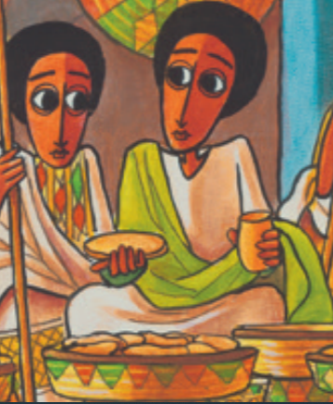
Liturgical colour | Monday | Tuesday | Wednesday | Thursday | Friday
Week 1 | LENT: LIGHT AND ENERGY  Genesis 1:1-3  I wonder if you marked the beginning of Lent with some pancakes. I wonder if you can remember anything that we learned about Lent in worship already. This week, we are going to think about various positive things we can ‘take up’ during the rest of Lent to make small differences that will help us and others.  I wonder what you think is the most important word in the first few sentences of the Bible.  In the beginning God created the sky and the earth…. Darkness covered the ocean…… Then God said, “Let there be light!” And there was light.  Light is certainly important as the first thing that was needed in our world. Here are some things for you to consider in relation to light, giving thanks to God, and wondering how your actions can make the world a better place:  Notice light around you: sit and watch the sunlight or a lightbulb or a candle (with an adult) and wonder about the difference that light makes to your lif.  Make small changes: turn lights off and chargers for mobile devices to save energy – the little things add up  Give thanks for light and warmth at home: almost a billion more people have electricity at home than they did just ten years ago  Share Jesus’ light with the world: I wonder how you will do that today.  Thank you, God, for the light and energy we use every day. May all countries act swiftly to reduce energy use and combat climate change. Help us to make small changes where we can. Help us to shine the light of Jesus wherever we are today and this week. AMEN | LENT: WATER  Psalm 65: 9-13  I wonder what this verse from Psalm 65 says to you. ‘You [God] take care of the land and water it. You make it very fertile. The rivers of God are full of water. I wonder how many things you can list that you can only do when you have water.  Here are some things for you to consider in relation to water, giving thanks to God, and how your actions can make the world a better place:  Find out about ‘virtual water’: how much water does it take to make a pair of jeans? A hamburger? I wonder if this surprises you. I wonder if this makes you think about using water more wisely.  Caring for local waterways: I wonder where there are ponds, rivers, canals in your area. I wonder whether these are kept clean and well cared for you. I wonder if you can to help with this.  Check your cupboards: with a parent or carer, see if there are any bathroom or kitchen products that could be switched to those with less harmful chemicals.  Praying for those who do not have enough water: I wonder where in the world is affected by climate change which means that water is short. Pray for courage and hope for those trying to help those affected by lack of water.  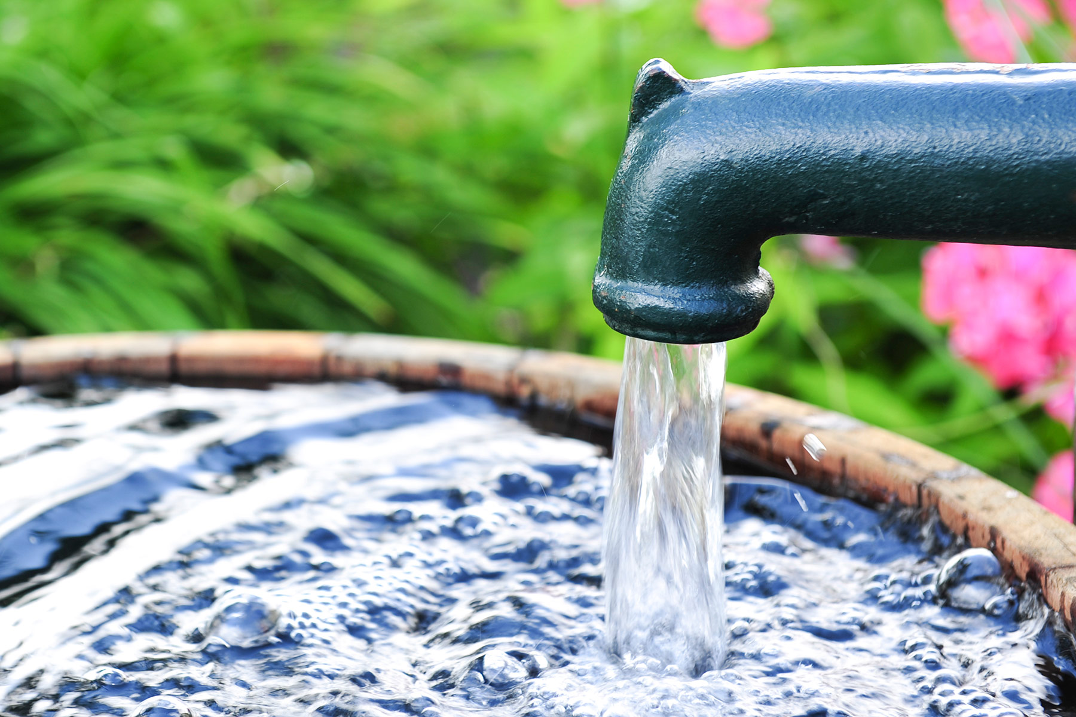  Creator God, we thank you for water to drink, cook, wash, and play with. We pray that everyone may learn to use water more wisely and share it more fairly. AMEN | LENT: LAND AND PLANTS  Genesis 1:9-13  I wonder if you can draw a picture inspired by this Bible verse.  The earth produced plants. Some plants had grain for seeds. The trees made fruit with seeds in it. Each seed grew its own kind of plant. God saw that all this was good.  Here are some things for you to consider in relation to land and plants, giving thanks to God, and considering how your actions can make the world a better place:  Get in touch with nature: spend time outside noticing any plants and trees - go for a walk or get wet or dig the earth (or all of these) if you can.  Find out how trees help the planet: research how our trees support people, animals and other plants.  Save paper and trees: think of ways you could use less paper and make sure you recycle all that you can.  ‘Prune your stuff’: explore how you can share and re-use things eg giving unwanted toys and games to other children or a charity shop  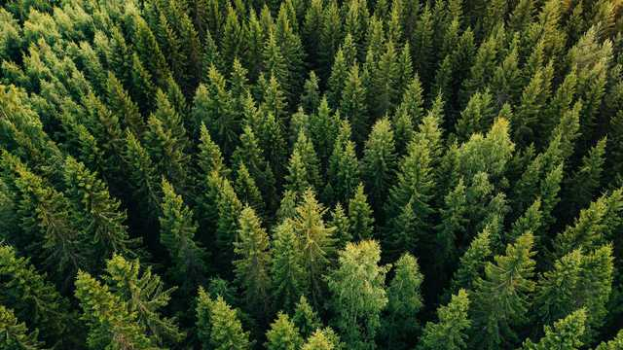  Loving Father, we praise you for the beauty and plenty of nature. Help us to do all we can to protect plants and trees and to tread more gently on the earth. AMEN | LENT: CREATURES OF SEA AND SKY  Genesis 1:20-23  God created the large sea animals. He created every living thing that moves in the sea. The sea is filled with these living things…..God also made every bird that flies…  I wonder how many different creatures of sea and sky you can list or draw or list.  Here are some things for you to consider in relation to creatures of sea and sky, giving thanks to God, and reflecting on how your actions can make the world a better place:  Explore the wonders of the deep: watch a nature documentary and/or do some research about the life in our oceans – thank God for your amazing discoveries .  Use less plastic: try and do this so that there will be less plastic damaging sea creatures  Look at the birds of the air: watch and listen for birds – there are many fewer than there were just a few decades ago. Perhaps you can put out food for the birds.  Lord of sea and sky, we bless you for the wonders of Creation. May the people of the world act together to ensure the oceans and air are protected rather than polluted. AMEN | MY LENT RESOLUTIONS  Genesis 1:31  Watch  https://www.youtube.com/watch?v=kMWr7eGJ1D8  up to 3 minutes, or similar or read a book about our planet  I wonder what amazed you most about our amazing planet.  Look back over the week and think about what you have resolved to do to make a difference in the world. Think about how you will do some of these things for the rest of Lent. I wonder if you could make them a part of your daily habits going forward so that you make that difference all of the ti  Creator God  Thank you for making this amazing world. Thank you for making it so beautiful. Thank you for loving every person you have made in the whole world. Please help us to look after the world. Please help us to look after each other. Please stop climate change hurting people and all your creatures. Please help us not to be greedy, and to trust you to give us enough. Please help us to share what you have given us. AMEN  (Tearfund “Hope for Creation “)  Songs  https://www.youtube.com/watch?v=0sUPK7LqAj8  https://www.youtube.com/watch?v=Ck6cCyvo5vo
Week 2 | IT’S NOT FAIR  Ecclesiastes 9:11  Day 1 provides an introduction to the idea of fairness with an exploration of Fairtrade for the rest of the week.  I wonder when you have said or heard the words, ‘it’s not fair’. I wonder what that means.  The writers of the ‘wisdom books’ of the Bible looked out at the world and realised that things did not always make sense/were not always fair. I wonder what this writer in the Bible had seen when he wrote the words.  The fast runner does not always win the race. The strong army does not always win the battle. The wise man does not always have food. The smart man does not always become wealthy. And the man with special skills does not always receive praise.  I wonder if you have ever seen or experienced anything like this. I wonder why it happened and how it made you feel.  This might be a better way of starting the conversation with younger pupils  https://www.youtube.com/watch?v=KoSUnJqJ7Yw  I wonder if there are any ways that you could think of to act to help make life fairer to those around you.  Jesus summed it up in this way:  ‘do to others what you would have them do to you’ (Matthew 7:12) I wonder how it would make for a fairer world if we all followed this simple rule.  Dear God, at times when the world does not feel like a fair place, help me to trust in you and know that you are alongside me, showing me how to respond and how to treat others fairly. AMEN | IT’S NOT FAIR - Fairtrade  Proverbs 31:8-9, Matthew 7:12  During Fairtrade Fortnight, Fairtrade is asking people to think about the world they want to see, and how they can help to shape it. Life is tough for producers of coffee, bananas, cocoa and many, many more products that we buy and enjoy. They may have to choose between providing nutritious food for their families, getting medicines when they are ill, or paying for ways to protect their homes and farms from climate changes. Everything on the planet depends on nature: for air that we breathe, water we drink, the food that comes from the plants that grow in the soil, trees to provide shade, and the weather to grow food and keep warm, also the things we enjoy for fun such as rivers to swim in, trees to climb, birds to watch, beautiful places to visit. Supporting the people who grow the things we love so that they can survive and thrive is part of looking after our planet and everything on it. We all need food, water, air, shelter and safety no matter where we are on the planet.  I wonder what it would be like to make difficult choices about looking after the planet or not looking after the planet if you were trying to make enough money just to survive. I wonder how hard that would be. I wonder how we could help.  You might use Hotel Necessita with older pupils  https://schools.fairtrade.org.uk/teaching-resources/primary-assembly-for-fairtrade-fortnight-2021-hotel-necessita-role-play/  or look at teaching resources  https://schools.fairtrade.org.uk/teaching-resources/climate-fairtrade-and-you-education-pack-for-primary-schools/  Dear God, show us how to make our whole world a fairer place to live in. AMEN | IT’S NOT FAIR - Fairtrade  Psalm 106:3, Matthew 7:12  ‘Happy are those people who are fair,  who do what is right at all times’. I wonder what you think this Bible verse might mean. I wonder if you feel happy when you are fair to others.  I wonder who likes chocolate. I wonder if you know how chocolate is made. I wonder who and what is needed to make your chocolate bar.  There is a quiz here about cocoa:  https://schools.fairtrade.org.uk/teaching-resources/primary-school-quiz-for-fairtrade-fortnight-2021/  Watch all or part of this clip about how Fairtrade is helping to ensure the fairness that we talked about yesterday (a shorter clip would work better with younger children eg the earlier part of the clip)  https://schools.fairtrade.org.uk/teaching-resources/guardians-of-the-rainforest/  I wonder how Fairtrade is making life better and fairer for this family and community in Africa. I wonder if you have ever seen the Fairtrade logo on chocolate that you buy. I wonder how buying Fairtrade items might be making the world a fairer place.  With an adult, make something that uses a Fairtrade ingredient, perhaps some chocolate, to help you to remember that we can all play a small part in making the whole world a fairer place.  The words of this song are a way of thinking about changing our world:  https://www.youtube.com/watch?v=T13JYd_oi54 | IT’S NOT FAIR - Fairtrade  Micah 6:8, Matthew 7:12  I wonder what your vision of the best world, planet and everything on it possible might look like. I wonder if there are ways to share your ideas with your family, friends and school community. I wonder how much of your vision relies on people’s attitude and behaviour.  I wonder if this verse from the Bible can give us some clues.  And what does the LORD require of you, but to do justice, to love kindness, and to walk humbly with your God?  These clips might get you thinking as well:  https://www.youtube.com/watch?v=rtkEv7otm8k  https://www.youtube.com/watch?v=DtzlxpDRiMk  Compassionate God, we ask you:  to fill us with your love,  to place in our hearts a spirit of courage, to move us to reach out to others in need. And lead us to play our part, so that now and in generations to come all your children may share in our hope for a better world. AMEN | Celebrate our positive choices  Micah 6:8  The choices we make can affect the planet and the people who live on it in positive ways. Make a list of the positive choices that you and those around you have made for the planet this week. I wonder how our choices could reflect the words of the Bible verse above.  Use a time of prayer and reflection to say:  Thank you for the positive choices you have made this week  Sorry for any negative choices you have made this week  Please for those who still need the world to change and be a better place  Although this was written for Harvest, this prayer helps us to think about working together for a better and fairer world:  https://www.christianaid.org.uk/resources/pray/september-meditation
Week 3 | THE BEST ADVICE (MARY)  John 2:1-11  I wonder what is the best advice that you have ever heard. I wonder what is the best advice you have ever given.  Here are some amusing examples from children to illustrate different kinds of advice as appropriate  https://www.funny-jokes.com/funny-advice-from-children  I wonder who you trust to give you the best advice.  For Jesus, his mum was there to give him advice early in his ministry, when he first started to show people that he was there to teach them about who God is and what God is like.  Use an appropriate version of the story or use a clip eg  https://www.youtube.com/watch?v=OilBJ5-GVE0  https://www.youtube.com/watch?v=s_Cbk4i37HM  Jesus and Mary, his mother, attended a wedding, in Cana and when the wine ran out, she gave the servants advice to do as Jesus told them to do and the water was changed into wine so that the celebration could continue.  Good advice which we can trust often gives us the confidence to work well with others and get the best out of each other. I wonder how you will advise well today.  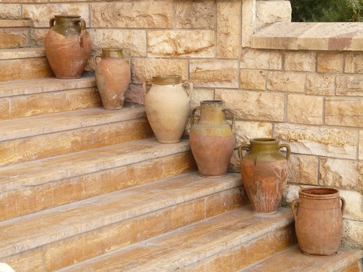 | THE GOOD NEWS OF CO-OPERATION  John 2:1-11  I wonder if you draw a picture of what you think of when you hear the word ‘co-operation’.  https://www.youtube.com/watch?v=LFTEeDOIRuQ (younger)  https://www.youtube.com/watch?v=TZqFYtWCWXg (younger)  https://www.youtube.com/watch?v=uL5mHE3H5wE (an advert that makes the point)  https://www.youtube.com/watch?v=gahtA5jv_KY (children’s voices)  Mary and Jesus co-operated to make sure that the wine did not run out of the feast – Mary asked for Jesus’ help, he agreed to co-operate and Mary told the servant to do exactly what Jesus said. There is lots of co-operation in this story.  We might not always think of ‘co-operation’ as the first association when we think of our relationships with those who care for us. But I wonder if there are ways that you co-operate with your family members day by day. I wonder if these are things that then help the whole of your family because it helps for there to be ‘give and take’.  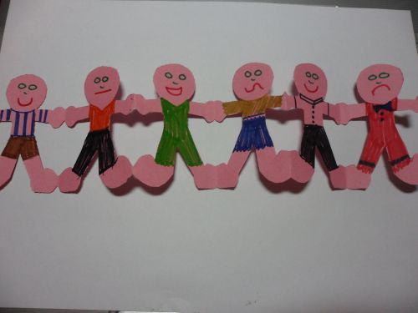  Think about the friends and family who love and support you. They are your team! Write a list of your team and choose a doll, cuddly toy, Lego person or similar to represent each one. Say one thing about the way that each person has loved, supported and cheered you on. If you want to, you can thank God for them too. | THE GOOD NEWS OF CO-OPERATION  Mark 3:13-19  Here are some quotations about co-operation:  ‘A burden shared is a burden halved’.  ‘Everyone likes attention and cooperation... but you'll only get it when you give it!’  ‘Few burdens are too heavy when everyone lifts’.  ‘Better together’.  I wonder if you could add any of your own. I wonder if you have any examples to show how you lived out the words of the quotations.  I wonder if you can remember any of the names of Jesus’ disciples and anything about them. (see Bible verses). As well as his family, Jesus chose a team to work with - see the stories of the calling of the disciples at the beginning of the gospels. Each disciple is different but they all need to cooperate to share the good news of the kingdom of God with others.  Even though we may not necessarily be able to meet with the friends who help us and make up our ‘team’, we can remember them. Make a small heart-shape as the centre of a friendship flower. Cut up coloured card into petal shapes to write or draw your prayer for those people for whom you wish to give thanks and say prayers for.  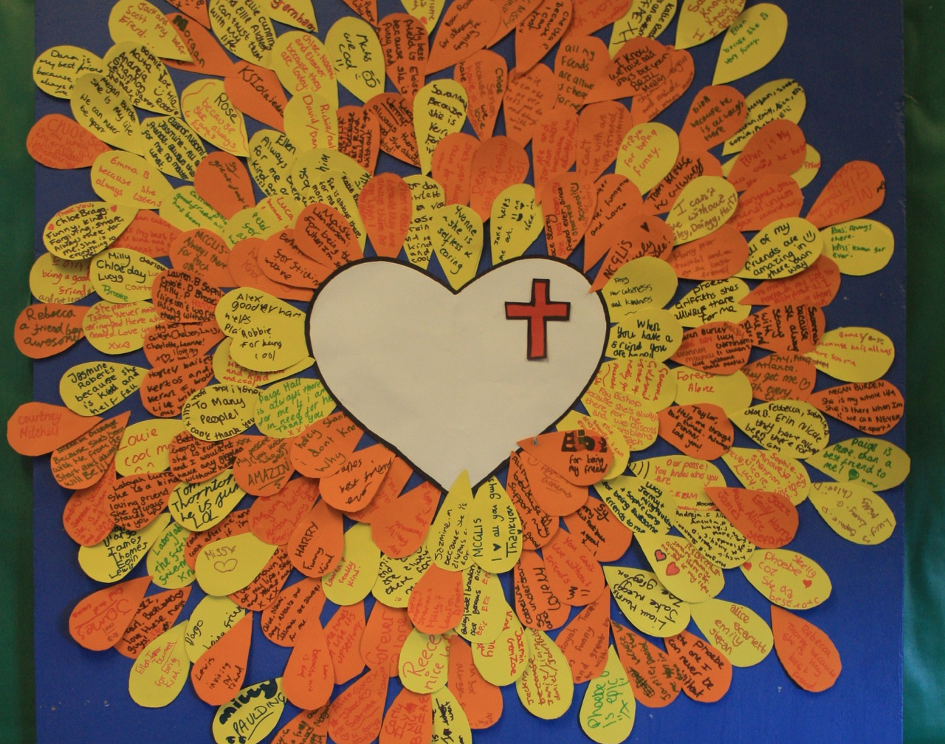 | THE GOOD NEWS OF CO-OPERATION Galatians 3:26-29  Reflect on ideas from this week encouraging pupils to think about the ways in which they live out ‘co-operation’.  Use this clip with older pupils to discuss what ‘I am Everyone’ might mean.  https://www.youtube.com/watch?v=1PuNxvdfhz8  ‘Orange’ ran a campaign using the slogan 'I am' and then added lines that suggest that each one of us is the sum of all the people that we have ever met (see clip above)  I wonder if you can think of anybody that Jesus met that he co-operated with especially anybody who was very different to those around them. I wonder how he co-operated with them and changed their lives. Breaking down barriers and bringing people together is at the heart of the Christian gospel. Even though Jesus was such a great role model for co-operation, his followers do not always to follow that example –so they need reminders such as that in the Bible passage today.  A picture of co-operation - fill in an outline of a body with lots of cut-out pictures of as many different sorts of people you can find. Include a wide variety of colour, ethnicity, gender, age etc  Dear God, show me how to co-operate with those I meet day by day because that is what you ask me to do. AMEN | CELEBRATE  our mothers and those who care for us  Isaiah 66:13  This coming Sunday is Mothering Sunday (or it might be a different week depending on the year in which you use these suggestions)  You could use this set of images and ideas to think about what your mother and those who care for you day by day mean to you – what they do for you but also the feelings you have for each other https://www.youtube.com/watch?v=0NVp_MCgNrU  Perhaps you could make these ideas into a card or booklet for your mum or carer/s as a thank you to give to them on Sunday with lots of love.  I wonder what ‘God the Mother’ (at the end of the images) makes you think of. I wonder how God could be thought of as a mother as well as a father. I wonder if this is a helpful picture is helping us to understand more about what God is like.  Prayer  Thank you for this promise:  God says: Point upwards then touch mouth  As a mother comforts her child, Rock baby gestures  so will I comfort you. Hug self  (Isaiah 66:13)
Week 4 | JESUS IS AMAZED  Luke 7:1-10  As we look ahead to the journey toward Jerusalem and the events of Easter, this is a week to look back and remember Incarnation (Jesus, God as man) and Gospel (the good news that Jesus brings) and linking to Salvation (the ‘Easter’ concept).  Remember to be sensitive to the needs of individuals in exploring feelings and emotions and provide support if needed.  Use a clip or tell the story of the centurion who came to Jesus  https://www.youtube.com/watch?v=iQdhT0WXoLw  https://www.youtube.com/watch?v=97a0fLC4S-0 up to 2 mins 40 secs  I wonder why Jesus is amazed at the centurion’s faith. I wonder what you have experienced recently that has made you say ‘Wow!’. I wonder why Jesus was so surprised in this story. If Jesus could be surprised by people, I wonder what this might teach us.  I wonder if you have any questions to ask. I wonder if you have learned anything about yourself. I wonder if this story helps you to understand and accept the amazement that you feel.  Jesus recognises the power of the centurion’s faith – this is a song about how a little faith can do great things:  https://www.youtube.com/watch?v=HPylxzfN-Oo (with actions)  https://www.youtube.com/watch?v=xECxevPcRBs (words only) | JESUS FEELS COMPASSION  Luke 9:10-17  Explore this story in which Jesus feels and shows compassion  https://www.freebibleimages.org/illustrations/feeding-5000/  https://www.youtube.com/watch?v=EYmJzAo9KbY  https://www.youtube.com/watch?v=UyXP-kQfooU  I wonder why, when Jesus saw the needs of the people, the Bible says that he had compassion on them. He performed a miracle and fed them with 5 loaves & 2 fish because they were hungry. I wonder what difference you think it makes to Christians to know that Jesus showed compassion when he saw that the people who had followed him into the hills were hungry and needed food.  I wonder if you have any questions to ask. I wonder if you have learned anything about yourself. I wonder if this story helps you to understand and accept the compassion that you feel. I wonder when you have felt compassion for the suffering of others.  Look out into our suffering world and pray for situations that need our compassion:  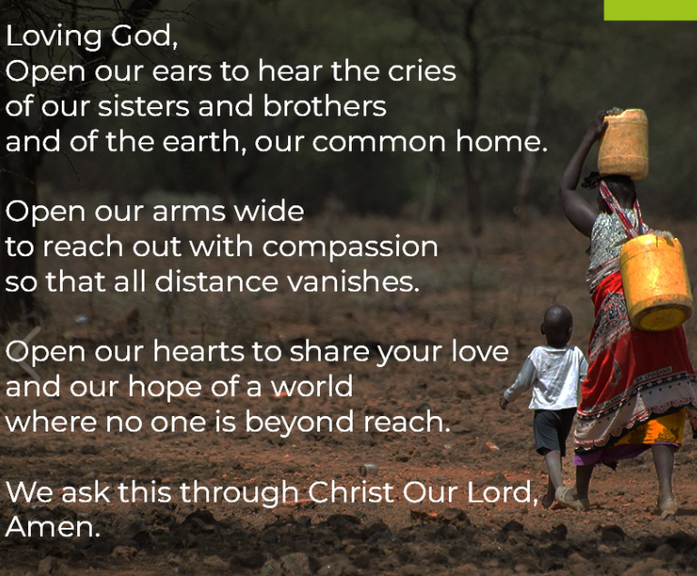 | JESUS IS ANGRY  John 2:13-22  Tell or show the story:  https://www.youtube.com/watch?v=WL0VY5FD6wA  https://www.youtube.com/watch?v=boNIL1owRAI  Note that Jesus does not hurt or harm anyone in this episode – but he displays anger at things that he sees as dishonouring to God, his father.  I wonder what emotion you think Jesus is showing here. I wonder if it surprises you to know that Jesus could be angry. I wonder what you think made Jesus feel this way. I wonder if you think that Jesus was right to do what he did. [He said that the Temple was a place for prayer, not selling things. The sellers were also stopping people from coming into the Temple to pray.] I wonder if being angry can sometimes be a good thing. I wonder how we might learn from Jesus’ example here. I wonder why it is important to be allowed to express anger – but not to act in a way that hurts others.  I wonder if you have any questions to ask. I wonder if you have learned anything about yourself. I wonder if this story helps you to understand and accept the anger that you feel.  Here is a prayer for when we experience anger about a situation:  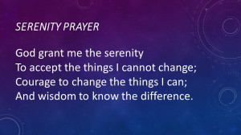 | PRAYING ABOUT WHAT WE FEEL  Ephesians 6:18  ‘Pray with all kinds of prayers, and ask for everything you need’.  Christians would say that Jesus feeling amazed, compassionate and angry gives them permission to feel these things as they experience the world as it is around them. This means that, no matter what, they can bring all the confusion, hurt and pain – as well as joy and wonder – that they feel to Jesus, believing that he understands.  Spend some time in quiet, bringing all your emotions – the more difficult ones as well as the easier ones – before God, or holding them in your heart if you prefer. Think about the people around you who support you when you need them and give thanks for them.  Use your hands to express this response – if your children know the BSL or Makaton signs, you could use these instead of the suggestions.  When I am angry [close fists tightly]….. Thank you God, that you understand me [open hands out and up]  When I am sad [use fingers to draw tears on your face]…. Thank you God, that you understand me [open hands out and up]  When I am worried or afraid [hide behind your hands]… Thank you God, that you understand me [open hands out and up]  When I am amazed [clap hands]…. Thank you God, that you understand me [open hands out and up] AMEN  Alternatively, use a container in which pupils can put their written or drawn emotions as a prayer or reflection. | SHARING our emotions  Romans 12:15  I wonder when we have felt amazed or compassionate or angry. Children and grown ups feel different emotions many times – sometimes they happen in the same day as different things happen. It is important to talk about them with someone that you trust who can help you to deal with how you are feeling in ways that are safe and support you.  The Bible tells us that Jesus felt these emotions and so he understands when we feel them too.  Dear God, Be with us when we experience the same emotions that we see in Jesus, when we feel amazement, compassion or anger. May we grow through them with you alongside us. AMEN  One of our well-known Christmas carols describes this:  For he is our childhood's pattern: day by day like us he grew, he was little, weak and helpless, tears and smiles like us he knew;  and he feels for all our sadness, and he shares in all our gladness.  https://www.youtube.com/watch?v=tRIZ22dn-XY  (at 2 mins)
Week 5 | PALM SUNDAY  Mark 11:1-11  Find out what happened on Palm Sunday. Here are some clips  https://www.youtube.com/watch?v=lQfHfOOvBuM (up to 1 min 45 secs)  https://www.youtube.com/watch?v=F7r2jaciG0g (up to 1 min 54 secs)  Alternatively use an appropriate Bible version – here are images to bring the story to life  https://www.freebibleimages.org/illustrations/ls-palm-sunday/  I wonder what this story tells you about who Jesus is and what Jesus is like? I wonder why people found palm branches and shouted ‘Hosanna’. Perhaps this clip will help you to think about this in relation to fairly recent events especially the procession and cheering crowds.  https://www.bbc.co.uk/newsround/65508301  I wonder what makes you clap and cheer.  For prayer/reflection:  Make palm ‘branches’ by cutting out 4-5 hand shapes from green paper or any other paper you have at home and joining them together, slightly overlapping each other. Add a lolly stick handle or use a stick and secure it with sticky tape. Use one of the hand shapes and on each finger, write something to be grateful for (cheer about) or use your own hand to count your 5 ideas.  Songs related to Palm Sunday  https://www.youtube.com/watch?v=gSbEEwik2hs – lots of helpful images with this song  https://www.youtube.com/watch?v=Kht2SR8P0ko | EASTER: THE LAST SUPPER  Matthew 26:26-29  The images to accompany the Easter journey in six episodes are at:  https://www.imaginor.co.uk/wp-content/uploads/2020/04/JiELarge-pictures.pdf  Alternatively search for other appropriate images or use a Children’s Bible for each of the days of this Easter journey eg  https://www.freebibleimages.org/  https://www.nationalgallery.org.uk/paintings/the-easter-story  Look at The Last Supper by Nebiyu Assefa or a similar image  Reflection: The Last Supper, by the artist Nebiyu Assefa. I wonder what the disciples are thinking as he offers them the bread and the wine. I wonder why the disciples look puzzled and confused.  The Story: Jesus knew that the end of his time on earth was drawing closer. He wanted to share the special Passover meal with his disciples. As they ate together, Jesus did something unexpected. He took some bread and gave it to his friends saying “Take and eat; this is my body”. Then he took a cup and offered it round. “Drink from it, all of you. This is my blood which is poured out for many for the forgiveness of sins. Do this to remember me.”  Create: Using modelling material, old scraps of fabric, coloured bits of paper, or anything you have available, make a model or picture of the table in the story of The Last Supper or maybe recreate the scene using Lego or Playmobile figures. Add Post-it prayers for those who feel anxious or worried.  Thank you for giving us signs and symbols to help us remember who you are and what you have done for us. As we travel through the Easter journey together, give us a fresh understanding of your teaching and your love for us. AMEN | EASTER: THE GARDEN  Matthew 26:36-46  Look at The Garden by Nebiyu Assefa or a similar image  The Story: After eating supper together, Jesus and his disciples went to a place called Gethsemane where there was a garden. He asked three of his friends, Peter, James and John, to go further into the garden with him and to stay awake and keep watch while he prayed. Jesus was deeply troubled about what he knew would soon happen to him. Three times he went back to find his friends, but three times he found that they had fallen asleep.  Reflection: I wonder why the artist, Nebiyu, has used particular colours in his painting The Garden. I wonder how these colours help us to understand the feeling of those in the picture. I wonder how the colours make you feel.  Create: Colours are used by artists in lots of different ways to show emotion and feelings. I wonder if you can create some abstract art choosing particular colours to help you write or say a prayer for someone experiencing sad feelings today.  In the garden of Gethsemane your friends let you down and you felt frightened as you faced the future alone. We pray today for anyone who is lonely and afraid; help them to know that you are with them and that you love them very much. AMEN | EASTER: THE LIE  Matthew 26:69-75  Look at The Lie by Nebiyu Assefa or a similar image  I wonder what puzzles or strikes you about this image. Discuss this with someone and see what they might be thinking.  The Story: The darkness and peace of the garden where Jesus had been praying was suddenly shattered. An angry crowd carrying torches and armed with clubs and swords had come to arrest him and take him to the house of the high priest. The disciples who were with Jesus were terrified and fled, but Peter followed the crowd at a safe distance. When they all arrived at the place where the high priest lived, Peter waited outside in the courtyard. He sat warming himself by the fire, trying not to be noticed. But then people began to recognise him. They pointed at Peter. “Weren’t you a friend of Jesus?” they asked. Once, twice and then a third time Peter angrily denied even knowing Jesus! This was the moment that the cock began to crow and words that Jesus had spoken to him just hours earlier rang in his ears, “Before the cock crows Peter, you will disown me three times”.  Reflection: I wonder if you can identify Peter in the painting. I wonder how Peter’s hands tell us about what he might be saying. I wonder if we sometimes need to forgive or be forgiven.  Sometimes we are confident and brave but other times we get scared or embarrassed. We do not always stand up for what we know is right and we let you down. We are really sorry and ask you to forgive us, just as you forgave Peter. AMEN | THE JOURNEY IN MUSIC  You might want to pause for reflection on the Easter journey so far. I wonder what you have felt listening to the story this week. I wonder what the disciples might have been thinking or feeling.  I wonder if this music sung by Christians in Holy Week captures the journey so far.  Here are some suggestions – you may also have Easter music which you sing in school.  Palm Sunday  https://www.youtube.com/watch?v=tK6XuYhL7JI  https://www.youtube.com/watch?v=MD9rMkIS1yw  (traditional)  Last Supper  https://www.youtube.com/watch?v=JgHxVHUO_PU  https://www.youtube.com/watch?v=Egk-pX_1nHg  (spiritual)  The Easter story  https://www.youtube.com/watch?v=wjmMnhT7fOE  (traditional and modern mix)
Week 6 | EASTER: THE TRIAL  Matthew 27:11-26  Look at The Trial by Nebiyu Assefa or a similar image  The Story: Even though there was no reason to find Jesus guilty, the chief priests and elders of the people decided that he must be put to death. They took Jesus to Pilate, the Roman Governor for the region, to be condemned, but Pilate could not find him guilty of any crime. The chief priests and elders insisted, “We have a law” they told Pilate, “Jesus must die because he has claimed to be the Son of God.” Pilate was worried about this. He took a bowl of water and washed his hands to show that he would take no further responsibility for what happened to Jesus and he handed him over to be crucified.  Reflection: I wonder what you think about when you see Jesus’ hands are bound. He is a prisoner even though he has done nothing wrong. I wonder how it might feel to be unjustly accused and treated as a criminal.  Create: Take some dark paper (or paint white paper grey on one side). On the other side use collage, paint or pens to make that side of the paper as colourful and vibrant as possible. Now cut the paper into strips and use a stapler, paper clips or glue and make a paper chain. Keep the grey side of the paper on the outside. Use the paper chains to pray for prisoners (if appropriate).  Even in our time we know that Christians in some parts of the world are in chains or imprisoned, simply because they believe in you. Keep them strong and courageous and help them to feel your presence and peace today. AMEN | EASTER: THE CROSS  Matthew 27:45-61  Look at The Cross by Nebiyu Assefa or a similar image  The Story: Even though he was guilty of no crime, Jesus was hung on a cruel cross by his enemies. At the moment that he died the sun became dark, the earth shook violently and rocks all around, split apart. The centurion and those with him who were keeping watch, were terrified. They knew for certain now that they had witnessed before their own eyes, the death of the Son of God. As evening approached a man called Joseph from Arimathea, a follower of Jesus, went to Pilate and asked if he could take Jesus’ body away and put him in a tomb nearby, which was cut out of the rock. Pilate gave his permission. Joseph of Arimathea wrapped Jesus carefully in linen, laid him in the tomb and rolled a huge stone across the entrance.  Reflection: The eyes in Nebiyu’s paintings are often what we notice first. The only time that Jesus’ eyes are shown closed is in this picture. He has died. The sun has stopped shining. The world is a dark place. There are 6 other characters in this picture. I wonder if you can choose some of them and draw a thought bubble for each of them.  Create: Making Easter gardens is a tradition all over the world. They can be created using any materials that are at hand. If you are going outside today, collect some natural bits and pieces from the ground. Perhaps you can make a cross from two sticks. On Good Friday, the garden will be quite plain but on Easter Day it will be transformed!  Thank you that on the very first Good Friday, you stretched out your arms on the cross and embraced the whole world in love. AMEN | EASTER: THE EMPTY TOMB  John 20:1-18  Look at The Empty Tomb by Nebiyu Assefa or a similar image  The Story: On the third day after Jesus had been crucified and whilst it was still dark, Mary Magdalene went to the garden tomb where Jesus had been laid. As she drew nearer, she noticed, with alarm, that the huge stone that had been in front of the entrance had been rolled away! Bewildered, Mary raced back to the disciples who immediately returned with her to see for themselves. It was true, the tomb was empty and Jesus’ body was no longer there! Shocked and confused but realising there was nothing to be done, the men went home again but Mary stayed. She had never felt more alone and she wept bitterly. Bending over once more, Mary looked into the cave. To her amazement, she saw two angels in white, seated where Jesus’ body had been. “Why are you crying?” they asked. “They have taken my Lord away” she said “and I don’t know where they have put him.” At this moment Mary turned and saw Jesus standing there. At first she did not recognise him but then he spoke her name, “Mary”. Her face lit up, her tears turned to joy and her heart was ready to burst. She had seen him with her own eyes, Jesus was alive!  Reflection: I wonder why Mary did not recognise Jesus. I wonder what you notice about Jesus’ hands and feet in this picture. I wonder why it was important for Mary to see these.  Create: Fill your Easter garden with lots of colour. Pull apart the grey chains from Thursday to reveal the colour inside. Make an Easter cross with the pieces. What was dark and cold is vibrant and alive!  We celebrate that you rose again on Easter Day! Let your light shine into every corner of our world and may your love live in our hearts now and forever. AMEN | A TIME FOR YOUR EASTER SERVICE  Design your own special service with your pupil worship leaders. Use these images and your own favourite Easter music to reflect and celebrate with all of the school community.  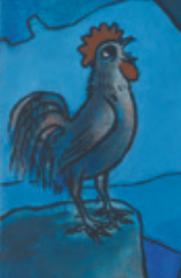  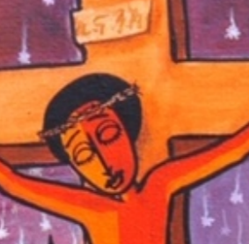  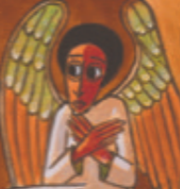  A happy and peaceful Easter to you all.

