Fresh Approach Collective Worship Planning
Year 2 Term 5

Week 1 | Easter Hope, living a life of hope
Week 2 | Courage
Week 3 | Love
Week 4 | Humility
Week 5 | Patience



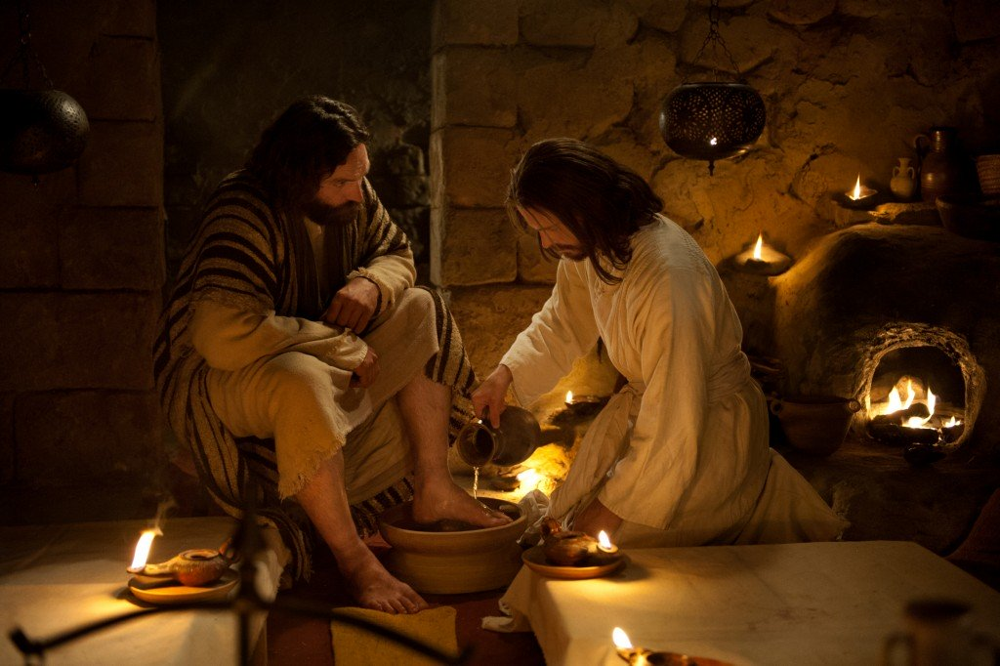
In week 1, there is a focus on hope, starting with the Easter hope that comes from Jesus’ resurrection.
From week 2 onwards, some of the ideas are based on the worship ideas provided on the Faith at Home website
https://www.churchofengland.org/faith-action/faith-home/i-am-school-leader
Just as our school communities live out their Christian values day by day, so the Early Church would have thought about how they could be good witnesses to each other and to those around them. This would not have been easy for the first Christians as they were always in danger of being punished for what they believed.
Some of the values here may reflect your own school values, but some will take you beyond those. This will help pupils understand that there are lots of different Christian values to live and learn from as they journey through life.
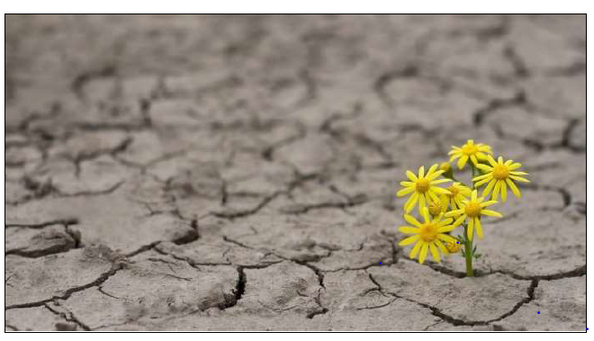
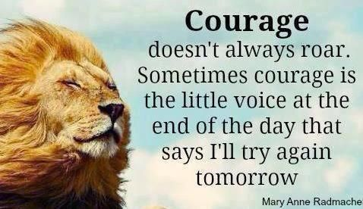
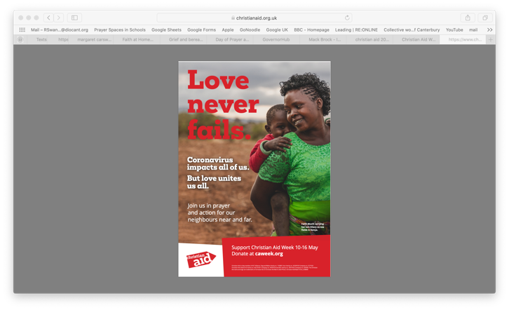
Week 1: Hope | EASTER HOPE  John 20:10-18  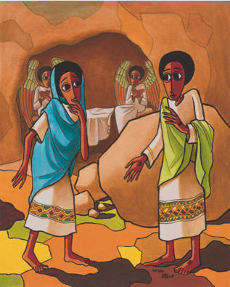  I wonder what you did to celebrate Easter over the holidays. I wonder if it was a joyful time.  Look at this painting, which is called The Empty Tomb by Nebiyu Assefa. I wonder if you can remember the story from the end of last term about Mary standing outside the empty tomb.  Read the story again looking at the painting. Hands always play an important part in Nebiyu’s art. What do you notice about Jesus’ hands and feet in this picture? Why do you think it might have been important for Mary to see these?  I wonder how Mary felt at the beginning of the account. Focus on feeling hopeless – nothing left to look forward to, all the things that Jesus’ followers had hoped for appeared to count for nothing. I wonder what she felt by the end of the account. Focus on the hope that she would have felt and taken back to the rest of the disciples.  For Christians, the resurrection of Jesus provides hope for the life they have in this world and also hope for a life to come. | EVERYONE CAN BE A HOPE CARRIER  Matthew 13 v 31-32  https://www.biblegateway.com/passage/?search=Matthew13%3A31-32&version=ICB  All or part of Hope primary https://www.thenational.academy/extracurricular/faith-at-home  might provide an introduction  I wonder what you think hope is like? I wonder how it starts and how it grows? I wonder how big it can become?  Watch this clip  https://www.youtube.com/watch?v=1-Z1etoGp0Q  How amazing is that! The Bible has a story that is a bit like that clip  Read The Parable of the Mustard  Seed (Matthew 13:31-32) ‘The smallest of seeds… becomes a tree.’  Plant a seed of some sort and, when it starts to grow, remember that you planted it and cared for it as a sign of hope, which you have waited for but gets bigger and bigger and better and better.  Read this together  ‘Hope is a baton, something to be held onto but also passed on. Hope comes to  us… to flow through us.’  I wonder what it means, especially just now? I wonder how hope might flow through you today? You could say a prayer to ask God to help you to pass on the baton of hope. | EVERYONE CAN BE A HOPE CARRIER  Matthew 13 v 31-32  https://www.biblegateway.com/passage/?search=Matthew13%3A31-32&version=ICB  I wonder if you can remember our parable from yesterday?  I wonder what seeds need to grow into plants and big, tall trees. I wonder what hope needs to grow.  Spend some time talking about this picture:  I wonder how it might be possible for this plant to be growing here. I wonder what makes hope grow in difficult situations.  I wonder what the smallest thing you can think of might be. I wonder if you can hold it in your hand. I wonder how something so tiny makes you feel.  I imagine that you are holding a tiny object you found at the start inside your hand and make a fist around it. Now think about the thing you hope for most right now, while holding your hand tight. As you start to open up your hand, say what you will do to help your hope to grow. Start with: ‘To help my hope to grow, I will…’ You might also like to say a prayer, asking God to help you or reflect on how you can help your hope and those of others to grow.  You might finish by singing This Little Light of Mine: https://www.youtube.com/watch?v=QCN893hzueQ | EVERYONE CAN BE A HOPE CARRIER  Matthew 13 v 31-32  https://www.biblegateway.com/passage/?search=Matthew13%3A31-32&version=ICB  Look at what some pupils and teachers said that their hopes were at the beginning of a school year by watching  https://www.youtube.com/watch?v=dlcU5uHMdTM  I wonder if you could make your own ‘blackboard’ with your hopes and those of others in your class or school at the beginning of a new summer term.  As appropriate, allow time for everyone to talk about more challenging things:  I wonder if you ever find it difficult to be hopeful. I wonder if there are any particular places or people in particular need of hope just now. You might write/say prayers for them.  Dear God, we thank you for giving us hope when we feel worried, when we are having a hard time, when we don’t know what’s ahead of us and when we are sad. Thank you that  even the smallest seed of hope can grow into a big, tall tree. Please help us when we find it hard to be hopeful, so we can offer hope to others. Amen | Celebrate  Our hopeful world  As we come experience Spring and new life breaks out around us, let’s take the opportunity to be thankful for new life, colour and energy in nature.  I wonder if we are thankful enough for all that God has given to us.
Week 2: Courage | DAVID AND GOLIATH  I Samuel 17  Courage is often about continuing to do what you would normally do when faced with extraordinary situations. This is exactly what the first Christians would have needed to do as they were in danger of being punished or even killed just for believing in Jesus. The Early Christians would have looked at examples in the Jewish Scriptures as well as at the example of Jesus.  Many Christians believe that we should offer our skills, talents and abilities and that God will use that courageousness to achieve great things. The word ‘courage’ comes from the Latin word ‘cor’ – heart. All or part of Courage primary https://www.thenational.academy/extracurricular/faith-at-home  might provide an introduction  I wonder what you think of when you hear the word courage. I wonder who or what you think of when you hear the word courage. I wonder if you can think of a time in your life when you had to be filled with courage. Find a small stone and hold it in your hand. Could something this small make any difference to anything?  Explore the story of David in Goliath It is in 1 Samuel Chapter 17 of the Bible.  https://www.google.com/search?q=davis+and+Goliath+youtube&rlz=1C1CHBD_en-GBGB806GB806&oq=davis+and+Goliath+youtube&aqs=chrome..69i57j0i13i512l3j0i22i30l6.6711j0j7&sourceid=chrome&ie=UTF-8#fpstate=ive&vld=cid:6a2faf53,vid:_VCHO50wOE0  Let the story speak for itself today – reflect by looking at the small stone again. | SHOWING ALL SORTS OF COURAGE  I Samuel 17 and Psalm 23  Re-visit the story from Monday  I wonder why David had to show such great courage. I wonder if your worries and anxieties can sometimes feel like ‘giants’.  Think about these things, you may like to draw them or write them down. Find someone you trust to talk about your ‘giants’. It is always better to share your worries with someone else. It is ok to feel worried or anxious about these things. Many Christians believe that God promises to help, guide, strengthen and fill them with courage, just as he did David. I wonder if you need some courage to face your ‘giants’ like David did.  When David said he would fight Goliath, his eldest brother was angry and said that David was conceited (“cheeky brat” Good News Translation). David then went to others in the army and each time he got the same answer. I wonder how this story might have ended if David had given up when his brother was angry with him.  Let’s look again at our small stone…  I wonder if it might be a reminder of the story of David and Goliath. I wonder if it might be a reminder that small things can make a big difference. I wonder if it might be a reminder that a little bit of courage and encouragement can go a long way.  You might like to read or listen to Psalm 23 (traditionally believed to have been written by David): this is a modern version of a Psalm that has given Christians courage in difficult times for generations: https://www.youtube.com/watch?v=pN4tPkX0MG0  Dear God, you know that I often feel frightened at the moment. Frightened about what will happen to me, to those I love and to our school community. But I know that you have been with me, I know that you will with us today, I know that you will be with me in the future. Give me courage to do the big things, the little things and the difficult things that will make a difference to someone else today. Amen | EXAMPLES OF COURAGE FOR US ALL  I Samuel 17  Think back to the account from the Bible from yesterday. I wonder how David felt when he faced Goliath. In some ways David felt no differently facing Goliath than he would have when facing a lion or bear that was threatening his sheep (he was a shepherd before he was a king) …he believed that the same God who gave him courage to do this would be with him in facing Goliath. That was the secret of his courage…  I wonder if there are people today who still give us examples of great courage?  Watch Captain Tom Moore https://www.bbc.co.uk/news/uk-england-beds-bucks-herts-52333127  Captain Tom Moore raised over £31 million for NHS charities, by doing something quite ordinary… walking. He could easily have said ‘I am too old to make a difference’. I wonder if you think that he showed courage.  Ordinary people that we meet every day show courage every day. I wonder what sort of courage they are showing. I wonder how you can encourage them. Take some time to say thank you for all those who will show courage in serving others today.  All through History by Nick and Becky Darke is a Christian song about God’s faithfulness in giving his people courage in times of need. Watch and singalong here - if you would like to https://www.youtube.com/watch?v=hQS2HHayr38 | THE COURAGE AROUND US  Micah 6 v 8  Think about this image and these words. I wonder what you think they might mean. I wonder if there have been times where this has been your experience.  Christians believe that they are are being courageous by living as God calls them to be. But what does the Lord require of you but to do justly, to love mercy and to walk humbly with your God’. I wonder what this verse from the Bible might mean. I wonder how we can act justly, show mercy and walk humbly just now in our families, in our school, in our community at this time.  Pray/reflect on how you can show courage in different and age appropriate ways wherever you find yourselves. | Celebrate  any examples of courage which you have seen in school or in the news this week.  Encourage each other to be courageous whenever there is an opportunity to do so.
Week 3: Love | LOVE IS AN ACTION!  1 Corinthians 13:4-13  You might like to start your worship for the week by watching this video clip  https://www.youtube.com/watch?v=8iIEvQNRs_M (selection of love songs!)  I wonder what you think worship might be about this week.  In his letters to the early Christian communities around the Mediterranean, St Paul encourages new Christian in various ways – the Corinthians passage unpacks how Christians should love others.  I wonder what love means to you  There are lots of different types of love, I wonder if you can think of any of these.  There is the love between brothers and sisters and other family members, love between friends, romantic love, love you have for your favourite food or the love you feel for your pets.  The Bible gives Christians a really clear description of what love is and what it isn’t.  Share the passage together, or you could use this video clip: https://www.youtube.com/watch?v=8F9_A7XIU6k  1 Corinthians 13:1- 8  As you read or listen to this passage, I wonder which line jumps out. I wonder if there is a description of love that speaks to you.  Dear God,  Thank you that your love is patient. Help us show patience with those around us. Thank you that your love is kind. Help us to extend kindness to others. Thank you that your love never fails. Amen | LOVE IS AN ACTION!  1 Corinthians 13:4-13  Thinking back to yesterday …  Love is …. How would you complete this sentence? What did you notice yesterday about how love was described in the Bible?  Love is an action. I wonder what you think about this. Do you agree?  I wonder how you know that someone loves you - hopefully through their actions, words and thoughts. I wonder if you think this description of love goes across all the different types of love we thought about already.  The Bible also talks about different types of love. Agape love is mentioned many times in the New Testament as it describes selfless, unconditional love. That means, doing something for others without expecting anything in return.  Discuss who might really need God’s love and our love at this time. Spend some time praying for them.  Reflect on the love which is described in this Christian song:  https://www.google.com/search?q=such+love+youtube&rlz=1C1CHBD_en-GBGB806GB806&oq=such+love+youtube&aqs=chrome..69i57j0i22i30l3.4299j1j15&sourceid=chrome&ie=UTF-8#fpstate=ive&vld=cid:fb5c7674,vid:q0FXLoD-rd4 | LOVE IS AN ACTION!  1 Corinthians 13:4-13  Look at this image, what does it make you think of?  I wonder how we can give love away. I wonder how this can be the sort of love described in the Bible passage. I wonder how this might make us feel.    You might like to take part in this prayer activity as you think about all those you love and what actions you can use to show your love. Draw around your hands and then cut them out, but keep the two hands joined together.  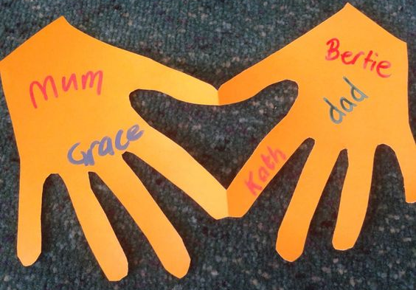  Can you see the heart in the middle of the two hands? Write the names of people you love on each hand. This could be family or friends. Use this as a reminder of people that you love. Maybe you could hold this when you are saying your prayers?  I wonder if you could think of any people that it is harder to love. Reflect on the love you might share with them. | LOVE IS AN ACTION!  Luke 5:17-26  The Bible story for today demonstrates Agape (selfless, unconditional) love. I wonder if you can spot it when you hear the story.  Luke 5: 17-26 tells the story of the paralysed man, who is brought to Jesus by being lowered through the roof by his friends.  https://www.youtube.com/watch?v=FFCe5iwTtFw (Song telling the story of the healing of a paralysed man by Jesus) https://www.youtube.com/watch?v=BpcJoPDF3v4 (Video clip telling the story - watch from 55s to 4.50)  I wonder why his friends did this for their friend who was paralysed. How were they showing Agape love? I wonder where you might have seen this type of love happening in your community, house or school.  Remember, love is an action. How could you show love to people with the things you do and so love people with your actions  If you would like to, use this format to write or say a prayer.  S – Sorry  T – Thank you  O – Others  P – Please  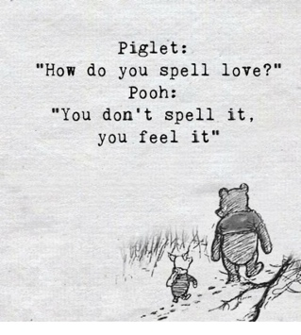  Dear God, I am sorry for the times when I haven’t loved people through my thoughts or actions. Thank you for all those that love me and for all those I love. Help my community to share love with each other through their actions. Please help me to love people in practical ways, especially those who are harder to love. AMEN | Celebrate  any examples of selfless love that have been seen in school this week.  Reflect on these words  What does love look like? It has the hands to help others. It has the feet to hasten to the poor and needy. It has eyes to see misery and want. It has the ears to hear the sighs and sorrows of men. That is what love looks like. St Augustine of Hippo
Week 4: Humility | HUMILITY TOWARDS OTHERS  Luke 18:9-14  Sometimes it is hard to be humble especially if you think you are right but that is the witness that the first Christians were called to - Christians today are still called to be humble.  This is a word that we do not hear very often. I wonder if you could explain what it means. I wonder if this clip might help you.  In 2018, tennis player Grigor Dimitrov hit national headlines. Watch: https://www.youtube.com/watch?v=Sd0EEHTJFgc. I wonder why you think Grigor was praised. I wonder if you can of any more examples of someone building someone up, rather than knocking them down.  Read the Bible story, in which Jesus speaks about two kinds of people.  or watch  https://www.youtube.com/watch?v=Ufe6zouTq8g  or use another appropriate version  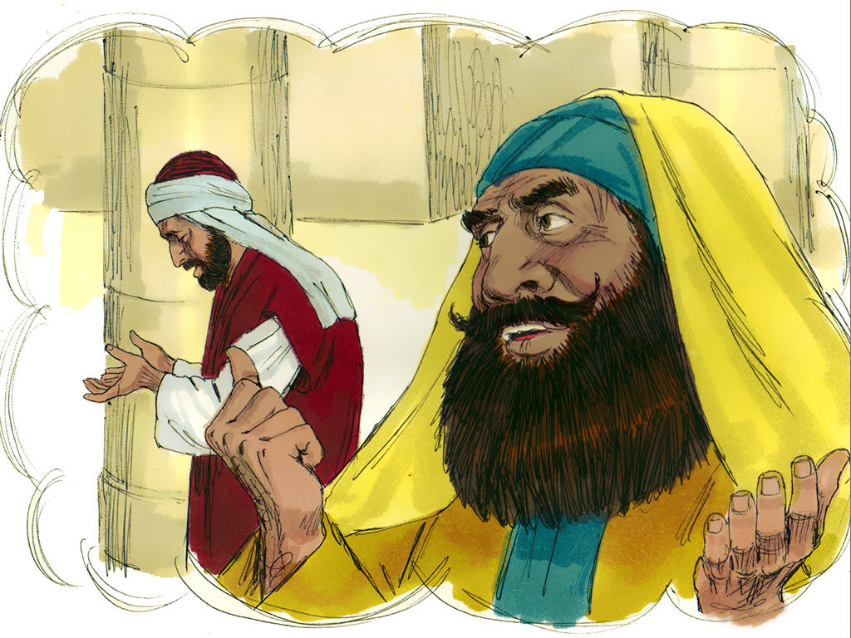  I wonder which person was humble in this story. I wonder why Jesus praised this person.  Loving God, you know we are not perfect. You see our mistakes and you know our thoughts and you know how great we sometimes want to be. Help us to change our perspective so that we take our eyes off the wonder of ourselves, looking at the wonder of others instead. Help us to see greatness in everyone, seeing your life within each person we meet. Amen. | HUMILITY WITH LOVE  Ephesians 4:2  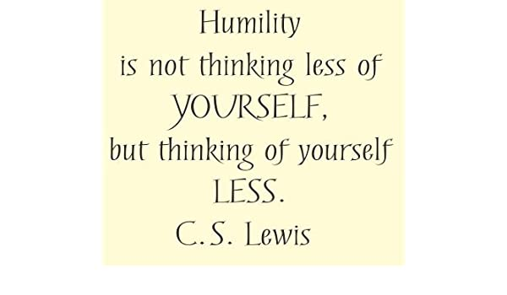  Look at the definition of C. S. Lewis on humility. Can you think of a definition of humility in your own words? I wonder what humility means to you. I wonder how you practise humility in your life. I wonder how how humility might draw someone closer to God or to others. I wonder how you can practise humility in your life this week.  Read Aesop’s Fable, The Hare and the Tortoise. How is pride and humility seen in this story? http://read.gov/aesop/025.html  or watch https://www.youtube.com/watch?v=FOy9y_zB8L4    Consider ‘Be completely humble and gentle; be patient, bearing with one another in love.’ (Ephesians 4:2). Create a Jar of Humility. Every day, write on a piece of paper saying how someone has helped you – it can even be help with the most thankless of tasks. Fold up the paper and place in a jar. After 7 days, empty out the jar and read some examples. Reflect on what these mean to you; you might like to say your own private prayer to God, giving thanks for the special people who have helped you with humility this week. | HUMILTY ABOUT OURSELVES  John 13:4-7  ‘Never look down on anybody unless you're helping them up.’ Jesse Jackson  I wonder if you have you had moments in your life where you have boasted, bragged or put others down to make yourself look good. I wonder if you have you had times when you’ve been humble, looking at the wonder of others rather than the wonder of ourselves.  I wonder if this account of Jesus, in Holy Week, helps you to understand what Jesus understood humility to be.  https://www.biblegateway.com/passage/?search=John+13%3A+4-7&version=GNT  Create a tower of shoes. I wonder…. how you could build others up this week …how others in your life help to build you up and support you …how we are not perfect – everyone makes mistakes and can accidentally knock people down. Remember, if we say sorry, we can help to rebuild relationships. I wonder how you might build others up and not put others down. You might also like to say a prayer to God, asking you to help with this.  This song might help you to think about Jesus’ example of humility https://www.youtube.com/watch?v=A0FSZ_iSYO8 | HUMILITY ABOUT OUR PLACE IN GOD’S AMAZING WORLD  Psalm 139:7-12  Watch Carl Sagan’s Pale Blue Dot: https://www.youtube.com/watch?v=GO5FwsblpT8 (older)  or  https://www.youtube.com/watch?v=kAGBqIA-fd4  I wonder if you are ever full of wonder when you see yourself as small in a vast and beautiful world and universe – take time to be small – but also special because we are part of it all. Humility means looking outwards with wonder and awe at the gift of everything that isn’t ‘me’. Take time to consider how special and wonderful we all are, and yet so tiny!  So everybody is a tiny dot, wonderful, important – but I wonder what we can do despite how small we are.  Thank God for ‘tiny’, amazing, wonderful you and for all the ‘tiny’, amazing people who love you, have loved you in the past and will love you in the future.  You might also think about how to live humbly in our world:  God our Father, show us  how to step gently,  how to live simply,  how to walk lightly  with respect and love  for all that you have made.  Amen | Celebrate  any examples of humility which have been seen in school this week.  Dear God, help us to know when we are being proud or when we have forgotten to be forgiving towards others. Help us to do what is pleasing to you. Amen.
Week 5: Patience | Patience with circumstances  Genesis 6:14-22  The first Christians had to have patience in times when it seemed that their new faith might not survive as they were persecuted for what they believed.  'Rome wasn't built in a day' - doing something worthwhile can take time, 'instant everything' isn't the answer to every problem. I wonder if you can think of a time when you had to be patient. Sometimes things that look simple have taken lots of patience to create, complete and perfect – such as https://www.youtube.com/watch?v=i3CEE9xKKZc (it took 6 weeks for 1 minute of film).  In the Bible, Noah finds that he has to be patient. God had told Noah to build a great big Ark. He had to take all his family and two of every kind of animal to save them from the coming flood. Noah had carefully followed God’s plan, Noah had to show patience with the animals and people he was locked in with and with the timing of God’s plan. He had confidence that God was with him, but he couldn’t see how the plan would work out. In Genesis 8: 6-13, you will find the end part of the story. For the full story you could watch  https://www.youtube.com/watch?v=yCLRcA9mlQE or find an appropriate version in a children’s Bible.  I wonder how patient Noah had to be. I wonder if you could say a simple prayer for more patience in any situation where you feel that you are losing or lacking in patience.  https://www.youtube.com/watch?v=0B_lnQIITxU  This song helps Christians to wait and trust in God’s promises and might help you to think some more about patience. | Patience with ourselves  Colossians 3:1  Here we will be thinking about not giving up, coping with temper, recognising our strengths and weaknesses, not being too hard on ourselves because we all make mistakes.  I wonder what you think when you join the end of a long queue. I wonder who you think of when your teacher asks you to think of someone who is patient. I wonder if you can think of a time in your life when you had to be patient and wait for something. How long did you have to wait? A minute? An hour? A day? A week? A month? Longer?  Re-cap on the story of Noah from yesterday.  I wonder what made Noah most frustrated.  I wonder what helped Noah to be patient.  If you had been in the ark, what would have made you impatient, and what would you have done about it? I wonder… if you have to feel patient, or if you can choose to be patient. I wonder how you cope when you have to be patient – maybe not cooped up in an ark, but maybe in a car on a long journey.  Paul wrote these words to one of the very first churches: he said ‘…clothe yourselves with compassion, kindness, humility, gentleness and patience’ (Colossians 3:12) So maybe patience isn’t always something that we have to feel inside first – maybe it’s something we can choose to put on, a bit like a jumper? I wonder if that makes a difference. If patience was an item of clothing, I wonder what it might look like. (Maybe something with lots of buttons, or shoes with laces!)  This quiet Christian song might be a way of helping you to sit calmly and asking God to help you to ‘put on’ patience now and keep it on for the rest of the day  https://www.youtube.com/watch?v=zY5o9mP22V0 – up to 1 min 10 secs | Patience with others  Proverbs 15:18  Today we will think about recognising that everyone is different, learning to make allowances for others, giving time to people, walking at another's pace and not rushing them.  This is a proverb from the Bible:  'Losing your temper causes a lot of trouble; but patient people bring peace' (paraphrase). I wonder what you think this might mean. I wonder if you have ever lost your temper or been in a situation where that happened. I wonder how you resolved the situations.  You could set up some scenarios that require patience or use a piece of knotted string because only slow, patient untying will work; if you rush, it just gets more and more knotted. If you want a story - Abraham was patient in waiting for God’s promise that he would be the father of the Jewish nation.  It might be helpful to acknowledge the things that cause people to lack patience with each other but not to forget the positive things that also happen when we learn to be patient with others and when they are patient with us.  Take some time to say:  Sorry for the times when we did not have patience  Please to ask for more patience in the future  Thank you for those who are patient with us | Patience with nature/the world  Genesis 1:31  This is about learning to wait for things to grow (harvest); working for change is one step at a time (for example, climate change); the more complex the problem is, the more time and attention it needs before a solution can be found.  Use this clip to show how patient animals are when hunting for food and how patient humans have to be to film them!  https://www.youtube.com/watch?v=sxYvbtE4Ybs  I wonder if you can think of times when we have to wait for God’s creation to show itself in its full glory.  Consider some practical action eg using a seed bomb which is a mixture of seeds from wildflowers and powdered clay. You can buy or make the seed bombs https://www.wildlifetrusts.org/actions/how-make-seed-bomb  with the help of an adult  When you have planted the seeds, you will need to be very patient! Make sure you water the soil and look forward to the time that insects and bees enjoy the flowers you planted!  One school asked their pupils to be patient wildlife photographers and send in photos of the creatures they saw around them on their walks.  Take time to give thanks that patience is rewarded in the beauty and wonder of creation. | Celebrate  any examples of patience which have been seen in school this week.    Reflect on these words  We could never learn to be brave and patient, if there were only joy in the world.  Helen Keller  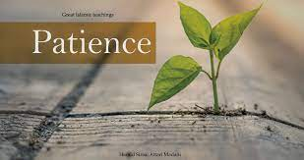
Week 6 | For week 6, we will point you to resources for the King’s Coronation which will be produced nearer to the time  