Fresh Approach Collective Worship Planning
Year 1 Term 4: Through Lent to Easter

Week 1 | Fairtrade: Thinking about Justice and Mercy
Week 2 | Lent: reading the signs
Week 3 | Glimpses of God’s Kingdom in Jesus’ parables  You will be able to use the Big Frieze to think about the concept of ‘Kingdom of God’ to enrich understanding as you look at the parables of the Kingdom (here and to come) in Matthew 13.
Week 4
Week 5
Week 6 | The Easter journey
This term encompasses Lent and ends with Easter. As we are in the Spring term, the focus is on the life and teaching of Jesus. Glimpsing images and ideas about the Kingdom of God through some of Jesus’ parables aims to deepen an understanding of how we can live our lives in ways which make a difference to ourselves and to those around us.
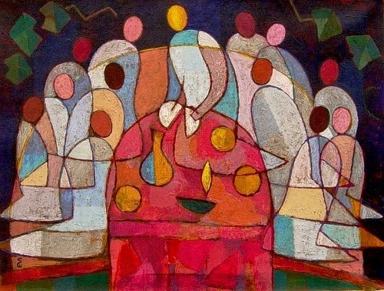
 | Monday | Tuesday | Wednesday | Thursday | Friday
Week 1: Fairtrade | WEIGHING IT UP  Proverbs 16:11  Invite two pupils up to the front to take part in a competition. You could pick one of the oldest pupils and one of the youngest. Say that you want to see who is best at catching, and you will give a sticker to the best catcher. Stand the older pupil really close to you, and throw the biggest ball for them to catch, making sure they can definitely catch it. Then say it is the next pupil’s turn, but this time stand them a long way away and throw a much smaller ball. Do your best to make sure they don’t catch it. Award a certificate to ‘The Best Catcher in School’. Wait for protestations from the rest of the pupils and ask a few to explain why what you have done isn’t fair. I wonder how you could have made it fairer? I wonder if the proverb from the Bible might help us to understand what we mean by fairness?  Have a set of balance scales heavily weighted to one side. I wonder how we could make them equal? I wonder why balance scales have often been used as a symbol for fairness because both sides must contain exactly the same. To treat people fairly, you have to give them the same chances.  God of fairness and justice, we pray for the desire to live by the rules of God's kingdom every day of our lives.  AMEN  https://www.bbc.co.uk/teach/school-radio/assemblies-ks1-ks2-what-is-fair/zwxcvwx | OUR NEIGHBOURS ACROSS THE WORLD  Mark 12:30-31  Use the Fairtrade quiz here  https://cafod.org.uk/Education/Education-resources/Fairtrade-school-resources  or similar questions to think about where we find Fairtrade and why it was important to those who decided to set it up. I wonder if you have ever seen the Fairtrade logo on goods in shops and supermarkets? I wonder why some people make the effort to find and choose Fairtrade goods when they do their shopping?  I wonder if Mark 12:31 helps us to understand more about the principles of Fairtrade?  I wonder how Fairtrade is trying to even up the scales as we thought about yesterday?  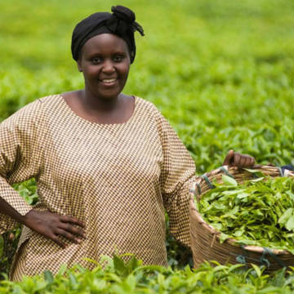  Dear God,  We pray for those people around the world who grow and produce the things we eat and buy. We pray that they get a fair price for the things we buy from them. We pray that we can help support these people by buying Fairtrade goods so that we can help create a better and more just world. Amen  Listen or sing  https://www.youtube.com/watch?v=b3NelRb1LY4  Find out more about Fairtrade  by visiting cafod.org.uk  fairtrade.org.uk | PAYING WHAT IS FAIR FOR WHAT WE BUY  Proverbs 3:27  Use one of these examples to show how Fairtrade makes sure that profits are fairly distributed so that all can live a good life:  https://cafod.org.uk/Education/Kidz-Zone/Banana-Fairtrade-game  https://cafod.org.uk/content/download/733/6290/version/17/CAFOD%20BANANA%20SPLIT%20GAME.pdf  or the Fairtrade cotton presentation  https://cafod.org.uk/Education/Education-resources/Fairtrade-school-resources  Whenever you possibly can, do good to those who need it.  I wonder what this proverb might mean in relation to the principles and practices of Fairtrade?  Lord God, grant that in our work  we may deal fairly with one another.  Fairness is both of the giver and the receiver. Give us the courage to challenge unjust practices, may we not walk by on the other side. May we have the grace to respect all, whether in work, or seeking it. We ask that all be given the opportunity to support themselves and their families by their efforts. We ask this through Jesus Christ our Lord. AMEN  (CAFOD)  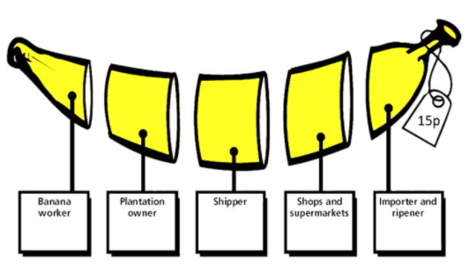 | MY PART IN JUSTICE AND FAIRNESS  Amos 5:24  I wonder what this verse might mean for our school community and for each of us as individuals? (think about this as appropriate to age group)  You might use images of:  - Some fairly traded goods or labels from them  - Pictures of people on a march or making a protest.  - A petition to be signed for some local issue.  - Two individuals in dispute who look unfairly treated.  - Global maps of our ‘rich and poor’ world  Think about the symbol for justice from earlier in the week eg ‘the scales of justice’ or perhaps some real old-fashioned scales. Think about commonly heard justice-related phrases such as: ‘It’s not fair’ – ‘fair enough’ – ‘fair play’- ‘ fairs, fair’ – ‘ a fair hearing’  ‘justice must be done’ – ‘we demand justice’- ‘justice for the poor’  I wonder if you always act fairly? I wonder if you are fair to other people? I wonder what unfair things make me cross? I wonder how school/community/world might be a fairer place? I wonder what God thinks is unfair in this world?  Dear God, show me how I can play my part in justice flowing like a river and goodness flowing like a never-ending stream day by day . AMEN | CELEBRATE  How people in school have made efforts to make the school a fairer place this week  Creator God,  you, who looked on everything that you had made and saw that it was very good, work now through us in our daily tasks,  so that in your grace we may use our creative skills for the benefit of all and help build your Kingdom of justice and peace.  Amen.  (CAFOD)
Week 2: Lent | JESUS IS TEMPTED  Matthew 4:1-11  At the start of his three-year public ministry, Jesus was baptized by John the Baptist in the River Jordan. Immediately afterwards he went into the desert of Judea, where he remained for forty days, not eating or drinking at all (‘fasting’). He needed to be quiet, to be alone and to pray at the start of the work for which God had sent him. He was tempted to use his powers to make people follow him; he was tempted to do things the easy way and not God’s way, but he did not acquiesce.  Think about the Bible account:  https://www.youtube.com/watch?app=desktop&v=dchKrbFOm9c&feature=youtu.be  https://www.youtube.com/watch?v=afzoWMTkKHY  https://www.youtube.com/watch?v=CN77fk1xNPQ up to 2:10  or Bible images  https://www.freebibleimages.org/illustrations/gnpi-014-jesus-temptation/  or art work  https://www.philipchircop.com/post/78978870751/christ-in-the-wilderness-stanley-spencer  I wonder how Jesus resisted the temptations put to him? I wonder how we can resist doing wrong things if tempted in different ways?  Dear God, may Lent be a time of quiet and reflection that makes me more able to look with honesty at myself and with compassion at the needs of the world. Amen | SHROVE TUESDAY  Daniel 9:3  This Bible verse refers to Daniel, who chose to stay to God by fasting which is one of the ways in which some Christians mark Lent.  This looks a bit like a pancake, doesn’t it?! In the past, people were supposed to use up all the rich foods in their kitchen, such as butter and eggs, before Lent starts, which is why we have pancakes. This was to prepare to fast during Lent and, in this way, to come closer to God. Explore the idea of pancakes in the way that suits you best!  During the 40 days of Lent, people who are Christians sometimes choose to give up something that they really like (reflecting the idea of ‘fasting’), such as chocolate, or TV, or computer games. I wonder how doing this over Lent relates to the episode of Jesus in the wilderness from yesterday? I wonder if we could give up some of the ways in which we behave that are not as loving or kind as they could be?  On this Shrove Tuesday, Lord help us to enjoy and give thanks to you for the very many good things you provide for us and remind us to share your gifts with others. And as Lent begins, prepare our hearts and minds to reflect upon the temptation of Jesus for 40 days and nights and what that might mean for us. Amen | ASH WEDNESDAY  Psalm 103: 13-14  Your school may mark Ash Wednesday in particular ways in partnership with your local church.  The traditions of Ash Wednesday for some Christians are also explored here:  https://www.youtube.com/watch?v=fQO4WHzhCcI  Living in ways which help Christians to draw nearer to God during is often hard work, because as human beings, we often find it easier to think about ourselves. But as we have learnt from the life and teaching of Jesus in our collective worship times, this is the example and challenge which we have been set. I wonder how we can set challenges for ourselves and our school community this Lent?  Say these words to encourage and challenge each other:  “Do all the good you can, By all the means you can, In all the ways you can, In all the places you can, At all the times you can, To all the people you can, As long as ever you can.” [attributed to hymn-writer John Wesley]  Seeing life as a pilgrimage/journey also reflects the challenges that we might meet:  https://www.youtube.com/watch?v=5yHJMPw8RHU | MY RESPONSE TO LENT  Matthew 4:1-11  Lent lasts for six weeks and is the 40 days before Easter in the Christian calendar (not including Sundays!). It is a time of disciplined preparation for the great festival of Easter—a time for getting spiritually fit. This is a these you could consider in an age appropriate way.  You might re-visit Matt 4:1-11 in this way  https://www.brf.org.uk/product/staying-on-task-jesus-in-the-wilderness/  or using some of the ideas  I wonder what we mean when we say that we are fit or need to get fit? I wonder what it might mean to be spiritually fit?  Christians see Lent as a time to stop and take stock of life and to make resolutions to do better in future. I wonder why they think that this is a good idea? I wonder if we can make some resolutions for the period from now up to Easter and check regularly to see if we are keeping them?  A very simple prayer/reflection space could be created with an empty bowl to represent what we are giving up to be filled with the things we are going to take up for Lent with some simple words of encouragement (possibly the words from Wednesday’s worship) | CELEBRATE  The ways in which we have been encouraged by those around us this week  The good news is that we’re not doing this alone: we have others around us to help us, and we can encourage one another to keep doing good…..We can ask God to help us too  Loving God, Help us to work together to share what we have, so that everyone has what they need. Help us to build a better world, where each of us can become the best person we can be. Help us to live differently during this season of Lent. Amen  [based on a prayer written by CAFOD]  With thanks to Faith at Home for this week’s material  file:///C:/Users/virginia.corbyn/Downloads/%23faithathome%20School%20resources%20Lent%20PRIMARY%20(2).pdf
Week 3: Glimpses of the Kingdom | KINGDOM RULING  Isaiah 11:1-5  Listen to this music  https://www.youtube.com/watch?v=w5A24zD27MQ  I wonder what it makes you think about? I wonder where this music might have been used?  It is used at Coronations such as this one:  https://www.youtube.com/watch?v=inKSvLk7kiI  It gives a new king or queen the authority to rule over their people – it gives both power over but also responsibility for their new Kingdom I wonder what powers and what responsibilities those should be? I wonder what qualities the new king or queen might need in order to exercise those powers and live up to that responsibility?  Look at some of the things which are associated with being a queen or a king eg orb, sceptre, crown.  https://thecrownchronicles.co.uk/explanation/symbols-of-monarchy-sovereigns-orb-and-sceptre/  I wonder if you remember the words from Isaiah 11 which we heard before Christmas which are words of prophecy about God’s kingdom, and the King who had been promised?  Isaiah 11:5 Goodness and fairness will give him strength. They will be like a belt around his waist.  I wonder what we can learn from this sort of king or queen and how it might help us lead our lives in school today? | KINGDOM SERVING  Mark 9:33-35  For the next few weeks, we are finding out, not about earthly kings or queens, but about God’s Kingdom, the things that Jesus said about it – and what difference it might make to us in our school. The people God were expecting a very different kind of king and kingdom – a powerful king who would get rid of the Romans and would lead them into freedom again. So Jesus needed to show and teach them about a very different king and kingdom.  Re-cap on the symbols from yesterday – the orb, the sceptre, the crown. I wonder what the symbols of Jesus the king might be?  Some ideas might include:  Cross – his throne  Crown of Thorns – his crown  Donkey – not a war horse (Palm Sunday)  Shepherd’s crook (I am the good shepherd)  I wonder what picture of a king this gives us and what we can learn from it? This is a rather topsy-turvy way of looking at being a ruler of a kingdom – summarised in these words of Jesus about the first being last and the last being first.  I wonder how we can put those words into practice in school today?  The words of this song give us a clear picture of Jesus as the Servant King:  https://www.youtube.com/watch?v=GrQiLEO4D5s  Creator God, make me a servant of your peace. Help me continue to pray and seek for your will to be done on earth, in me, as it is in heaven. Amen. | KINGDOM PARABLES: TREASURE  Matthew 13:44  I wonder which is best – old or new? We heard some of the puzzling things that Jesus showed and said about God’s topsy-turvy kingdom. I wonder whether you can remember any of these? When Jesus walked this earth, people often asked him about what the kingdom of God is like, and he often replied to this question (as he did with many other questions) by telling them a story – a parable, which is a story with a hidden meaning, a hidden treasure to search for. Tell the parable (which is only one verse as though you were part of the action - Something old, something new leaving pauses for children to think about and engage with the words and action.  Or use one of these:  https://www.youtube.com/watch?v=DeNP1wdYQf0  https://www.youtube.com/watch?v=-4OlyNE4OfM  https://www.youtube.com/watch?v=mTJDvd31gpc to 1:03  I wonder what Jesus was trying to teach the people who were listening? I wonder what followers of Jesus understand when they hear this parable? I wonder if anyone can learn from this parable? I wonder what you think this parable means? [talking partners, then share ideas]  Dear God  Thank you for the hidden treasure in the parables of Jesus. Help us to have open hearts and minds as we learn this week, to find new treasures in what we hear, and be reminded of old ones. Amen | KINGDOM PRAYERS: TREASURE  Matthew 13:44  Here are some ideas for sharing prayer and reflection in your classroom or around school having reminded everyone of the parable of the treasure:  1.Place a box of treasure (plastic gemstones / coins etc.) Hold a piece of treasure from the bowl in your hand as you think: what new ‘treasure’ might you find this week as you live and learn together? What ‘old’ treasures might you rediscover? As you place the treasure back in the bowl, you might like to give this week to God and ask him to help you as you learn.  2. Cut gold coin shapes out of yellow card. Children write or draw on them something that they regard as a ‘treasure’, new or old! Place these into the treasure box with the gemstones.  3. Use the same gold coin shapes and ask children to write on them a wise saying that they would like to share with the rest of the class. This could be ‘old’ – e.g. wisdom from a parent of grandparent or ‘new’, something they invent themselves.  4. Prayer Spaces in Schools have created a reflective activity thinking about our world – and the things we would want to treasure or change. https://prayerspacesinschools.com/resources/new-world/ | CELEBRATE  Treasures old and new in your school community  When we think of treasure, we often think about searching or seeking. The Kingdom of God is here but people have a part in seeking it and in working towards it as expressed in this song:  https://www.youtube.com/watch?v=9LMQfOp9w8k  In this song, Christians sing about how they are trying to live out God’s Kingdom here on earth.  https://www.youtube.com/watch?v=SZu5ndjwqUY  I wonder how we have been seeking to put into practice in our lives this week those things that are important in God’s Kingdom?  Thank you to Guildford Diocese education team for the great ideas about God’s Kingdom
Week 4: Glimpses of the Kingdom | KINGDOM GROWING  Matthew 13:1-24  Galatians 5:22-23  Look at all the different types of seeds in the PowerPoint: I wonder what they might grow into? (Show pictures to see what will be the result)  Today’s Kingdom parable is about a farmer and his seeds. I wonder if you can think about which seeds grew best and why as you listen.  Use one of these or your own version  https://www.youtube.com/watch?v=guDeSYcwRYg just animation  https://www.youtube.com/watch?v=W6LwEW8jX9A up to 1:30, then meaning  https://www.youtube.com/watch?v=JtvCJmMZbt0 up to 1:17, then meaning up to 2:50  https://www.youtube.com/watch?v=Sj4xEwh1MrY =Lego  Jesus wasn’t talking about real seeds or real fruit, but things like these [take fruits labelled with qualities from Galatians out one at a time from a fruit bowl.] The Bible calls these words the ‘fruits’ of God’s kingdom and God will help these things to grow in the lives of people who follow him, just like seeds grow into good fruit. I wonder how we can grow these good things in our lives, how our school’s values might help us, which of these ‘fruits’ are hardest to grow, what things might stop them from growing at all?  Dear God  Thank you for these good fruits of love, joy, peace, patience, kindness, goodness, faithfulness and self-control. Please help us to live our lives in ways that will encourage these good seeds to grow. AMEN | KINGDOM GROWING  Matthew 13:1-24  I wonder what seeds need to help them to grow? Discuss and remember your ideas.  Today use a different suggestion from Monday for the telling of the parable of the sower. As with all Jesus’ parables, it is so well crafted that you can hear the story over and over again, and ‘hear’ something new each time! (Remember that ‘old and new treasure’ that we thought about last week?).  Explain that, like all seeds, special seeds need to be taken care of in order for them to grow as they should. The focus here is on the good soil and making sure that the seeds sown in people’s hearts are looked after. As Jesus said in his parable, the seeds grow in good soil: that’s having hearts and minds that will listen and learn. But to really grow well, we need to practise/grow those good seeds sown in our hearts in order for them to become fully a part of us as a school community. Gardening can be hard work! But Jesus taught that God will help those who ask him.  Think about some words of David the Psalm-writer wrote in Psalm 19.  Here they are in a song:  https://www.youtube.com/watch?v=WIujiJXXb9A  Here are similar ideas as a prayer:  Dear God  May the words of our mouths [place your hands on your lips]  And the thoughts in our minds [place your hands on your temples]  And the attitudes in our hearts [place your hands over your heart]  Be pleasing to you [both thumbs up], our Father. AMEN | PEOPLE OF THE KINGDOM: St Patrick  II Corinthians 13:14  Here are some clips about St Patrick  https://www.youtube.com/watch?v=MqO0O8O8Gmk  https://www.youtube.com/watch?v=LmNc-NTfmPc  https://www.youtube.com/watch?v=xOqWT2tk9Js  or you can tell his story yourself  https://www.storynory.com/st-patrick/  St. Patrick is the patron saint of Ireland. On 17 March, people all over Ireland will have a holiday, remember stories about St. Patrick’s life, but above all, celebrate being Irish! It’s a colourful and noisy day. People wear green, play Irish music and take part in dances and parades and eat delicious Irish fare, such as soda bread & Irish Stew. Children have fun too searching for the St. Patrick’s Day leprechaun. All over the world, there Irish people celebrate on 17 March.  I wonder why the clover symbol, or shamrock, became the symbol of St Patrick? (three in one and one in three for the Trinity). I wonder how Patrick felt, knowing his beliefs were so different from the people around him? I wonder why beliefs are so important to people? I wonder what ‘picture’ you might choose to represent a belief that is important to you?  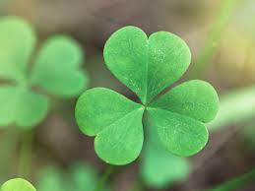 | KINGDOM PRAYERS: St Patrick’s Breastplate  This is part of a special prayer associated with St Patrick  Christ with me, Christ before me, Christ behind me,  Christ in me, Christ beneath me, Christ above me,  Christ on my right, Christ on my left,  Christ when I lie down, Christ when I sit down,  Christ in the heart of everyone who thinks of me,  Christ in the mouth of everyone who speaks of me,  Christ in the eye that sees me,  Christ in the ear that hears me.  I wonder if there is any part that you particularly like or have questions about?  I wonder what it tells us about what Patrick believed about God? I wonder how it might have influenced how he lived his life?  Here is music based on the words to help with thinking and reflecting:  https://www.youtube.com/watch?v=DgVQhonqPdI&list=RDDgVQhonqPdI&start_radio=1  https://www.youtube.com/watch?v=Xf8W6lTfwm8  https://www.youtube.com/watch?v=b21F-ZjfuYs  You could spend some time relaxing, whilst you reflect on things that you believe and use these Celtic colouring pages here, while you think:  https://www.colorwithfuzzy.com/celtic-coloring-pages.html | CELEBRATE  The ‘growing’ that has happened in school this week  Reflect on how we can grow as individuals but also as a school community even when we feel discouraged because of the support that we give each and from the encouragement of the example and words of Jesus  https://www.youtube.com/watch?v=Oy1RE7LS-Uk  O most merciful redeemer, friend and brother,  may I know you more clearly,  love you more dearly,  and follow you more nearly, day by day.  Amen  (Prayer of St Richard of Chichester)  Thank you to Guildford Diocese education team for the great ideas about God’s Kingdom
Week 5: Glimpses of the Kingdom | KINGDOM VALUE  Matthew 13:45-46  Play a game of ‘What’s it worth?’ Either play the game on screen, or gather your own objects The game could be played in several ways, dependant on the ages of your children e.g. order the objects from the least to the most valuable; having a team (like on a quiz show) who try to guess the price, maybe writing their suggestion for each in turn on a whiteboard; a hands-up version where children vote e.g. less than £10, over £1000 etc.; or children just taking a wild guess. However, do not lose the point that it is about VALUE.  I wonder what the word ‘value’ means?  Tell the parable using one of these https://www.youtube.com/watch?v=GvQoTXIBVFY a humorous take  https://www.youtube.com/watch?v=gAZb_WrTQnI up to 1:30  or in your own way  In Matthew 13, Jesus told a parable about something that was very valuable. The pearl is God’s kingdom – and when you know that, you can make sense of what Jesus was meaning his listeners to hear. I wonder what you think this parable means? I wonder why the merchant was willing to sell everything for this pearl? I wonder what Jesus was saying about the value of God’s kingdom? I wonder what questions this story makes you ask?  Dear God  Thank you for all the things that hold value for us – and the things that are completely price-less! Thank you for this parable of the pearl of great price, a story that helps us to think about the value of your Kingdom. Help us to know how to value one another this week. | KINGDOM VALUE  Matthew 13:45-46  Think about the 2 parables that we have met about valuable things: firstly, the parable of the pearl from yesterday and the treasure from two weeks ago  https://www.youtube.com/watch?v=DeNP1wdYQf0  Compare with the parable from yesterday – here is a reflective version (Godly Play)  https://www.youtube.com/watch?v=h-b3T7HfXYY – this might be a good focus on its own for a reflective act of worship  I wonder what the similarities are between the two parables? I wonder if they are giving the same message?  To listen to:  An old song, about treasure in nature:  https://www.youtube.com/watch?v=AwXLLwzEFpY  A slightly newer one, about everyone being different, but special, https://www.youtube.com/watch?v=UEvJzOxm6zs  or one to learn the actions here:  https://www.youtube.com/watch?v=_F5pr6gEkBU  Or this one about God’s kingdom being a part of every Christian’s walk:  https://www.youtube.com/watch?v=nZBhKp5_HwE&t=1s  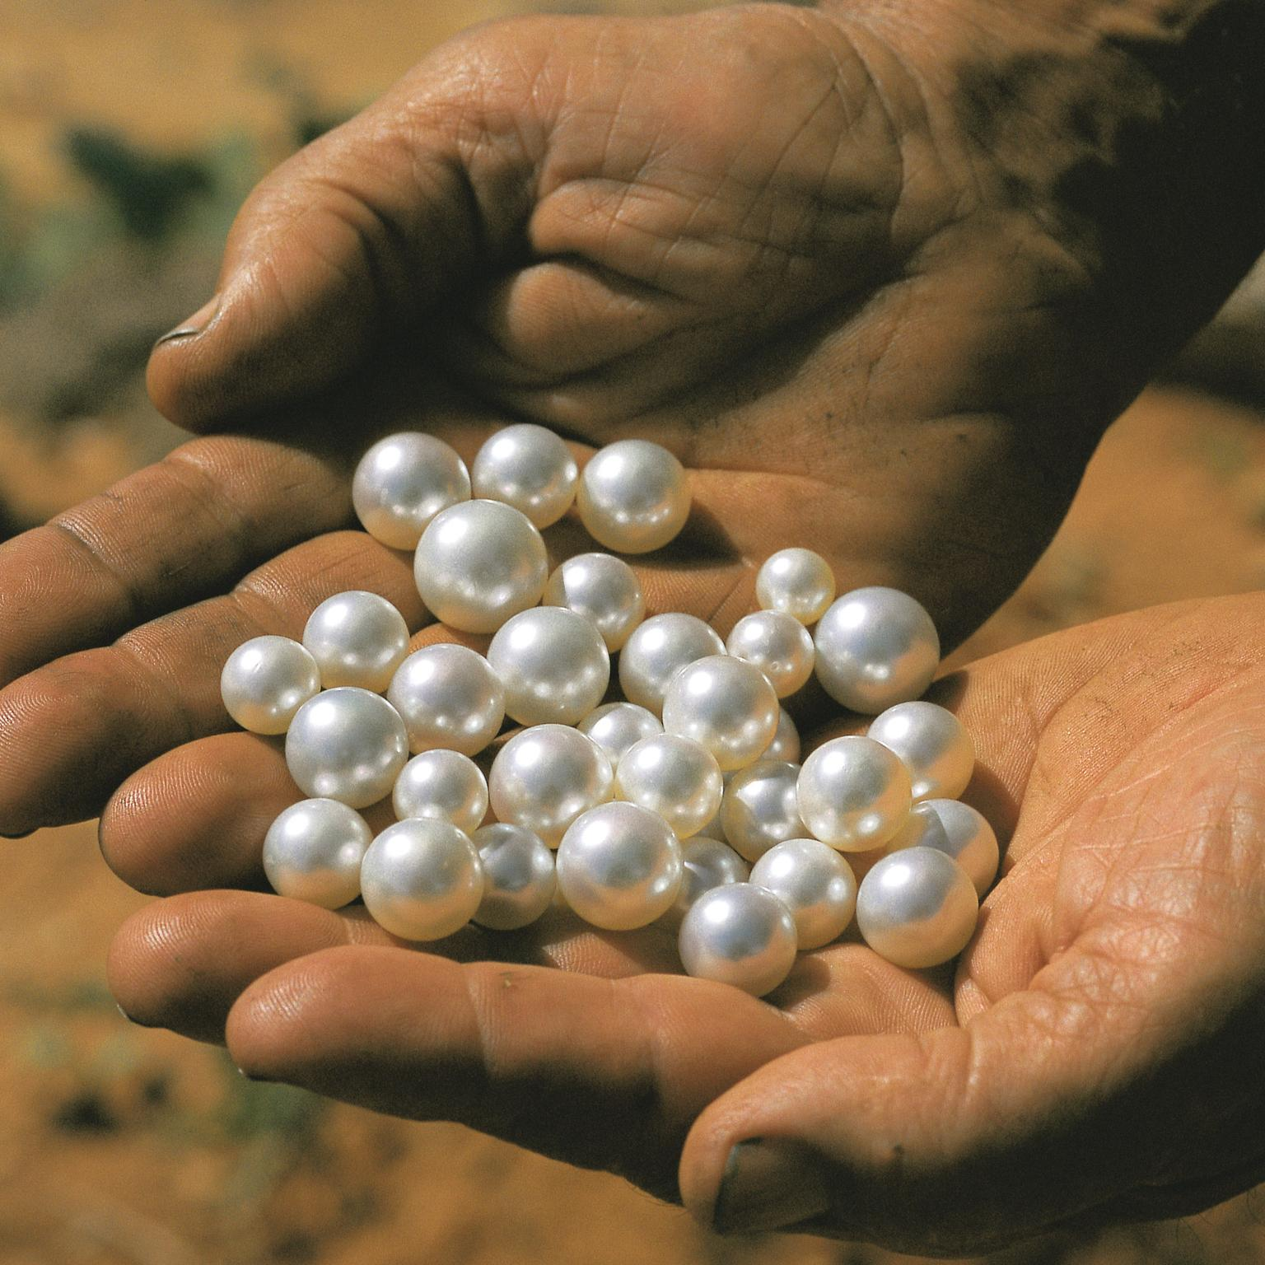  Dear God, Thank you for what we learn from the parables of the treasure and the pearl. Help us to see what is of true value and live our lives according to those truths. AMEN | KINGDOM CHOICES  Matthew 13: 47-48  I wonder why it is sometimes hard to make good choices? Today we start looking at one last parable about God’s kingdom. These parables of the kingdom were stories Jesus told to help his followers to know how to live as part of God’s kingdom. This parable is about fishing, which was something that Jesus’ disciples knew a lot about.  Tell the parable – you might be able to use images of fishing from the time:  https://freebibleimages.org/photos/galilee-fish-nets/  I wonder what you think Jesus was meaning in this parable? I wonder how the fisherman might choose what’s good and what’s bad? I wonder what the fish might represent? People often accused Jesus of teaching them hard things: the message in this parable was a hard one about making Kingdom choices – and about the consequences of making bad choices.  To practically think this through, use a fishing game called Good Fish, Bad Fish. In a net/bag, have good fishes with good choices, and bad fishes, with bad choices. I wonder when making good choices is difficult?  May the words of our mouths [touch lips]  The thoughts of our hearts [touch heart]  And the choices we make [hands at shoulders, open palms – like the ‘What?!’ emoji]  Be pleasing [thumbs up] to you, O God. Amen. | KINGDOM CHOICES  Matthew 13: 47-48  Think about the parable of the net/fish. I wonder what you remember about it and about what it might mean for us?  Some practical ideas – as suits age group:  1.Make your own sorting fishing game based on the idea of choices. Write your own situations as a class / group / individual and have others play your game to see whether they can choose the ‘good fish’.  2.Build a Jenga tower then as you remove blocks, think about the things that sometimes get in the way of making good choices. As you re-build the tower, you might like to ask God to help you to make good choices, or think about the people or strategies that help you.  Other ideas:  Watch this child-friendly reading of some words of Paul in Romans 12: 9-21  https://www.youtube.com/watch?v=vLYzxRxwigw  which might help you to discuss good choices  A Prayer Spaces in Schools idea about making good choices with a focus on the environment:  https://prayerspacesinschools.com/resources/carbon-footprint/  To listen to:  Some songs that relate to making good choices:  https://www.youtube.com/watch?v=xT_8U8oTUm0  https://www.youtube.com/watch?v=q4T37EaW4eU | CELEBRATE  The good choices made in school this week  Dear God, I try to make good decisions. But sometimes I am weak, I slip, I fail, I am unwise. Thank You for Your forgiveness when this happens. I pray for Your wisdom to guide me and that I can make good decisions for me and for those around me. Help us all to encourage each other to make good decisions based on what Jesus does and says. AMEN  A song asking about choices we/people might be asked to make:  https://www.youtube.com/watch?v=B7a7LdgRh-k  Thank you to Guildford Diocese education team for the great ideas about God’s Kingdom
Week 6: Looking forward to Easter | PALM SUNDAY  Luke 19:28-38  It is important that pupils understand how Holy Week unfolds and how there were different attitudes to Jesus, how the welcome of Palm Sunday changed to the calls for Jesus to be killed. I wonder why not everyone understood what Jesus came to show and to teach?  https://www.youtube.com/watch?v=VIUk0YCi15w to 2:48  https://www.youtube.com/watch?v=rdyJO-_aAv8 to 2:00  https://www.youtube.com/watch?v=rYZMhaRepJk start at 2:10 to 4:13  Alternatively use Global Christian resources to tell the story and explore the idea of Jesus the King riding on a donkey as foretold in Zechariah 9:9 using images from across the world  https://globalworship.tumblr.com/post/82297126034/resources-for-holy-week-palm-sunday-2014  Lord of the palm procession and hosanna praise,  may your humble kingship  be the pattern of our service,  for the sake of all who suffer and are in need  along the streets of our world.  Amen  Sing or listen:  https://www.youtube.com/watch?v=tK6XuYhL7JI  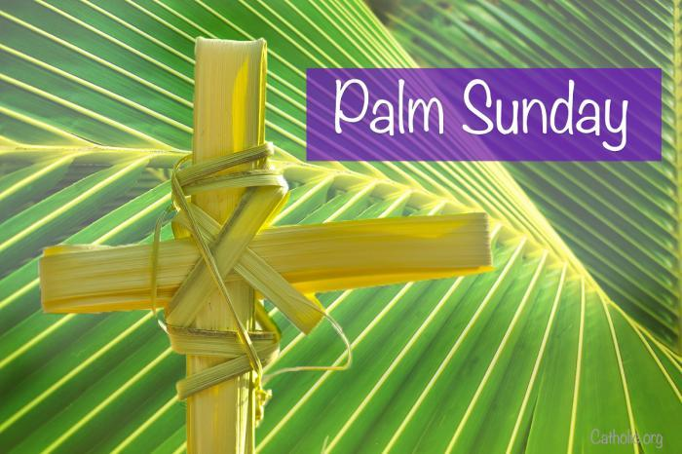 | JESUS IN THE TEMPLE  Luke 19:45-48  I wonder if rules are always good? I wonder if you can think of any rules that are not right or just? Jesus could sometimes be very awkward when he came across bad rules that hurt people, and that earned him enemies among those who set the rules. One day, he decided to make a stand against some very bad rules. In his time, it was believed that if anyone wanted to give money to support God’s work, it had to be expensive special money that you could only buy from approved dealers at the big temple in Jerusalem. The priests running the temple were quite happy about this, because it brought in extra cash.  A famous image of Jesus showing his anger in the Temple is by El Greco:  https://www.nationalgallery.org.uk/paintings/el-greco-christ-driving-the-traders-from-the-temple. This might help you narrate what happened in the Temple.  I wonder if, next time we get really angry about something, if it will be because we just feel grumpy or because we see something genuinely wrong that needs to change? I wonder if any of us have got a bad rule or two stuck in our own heads, telling us it’s OK to make life harder for others when we feel like it? And I wonder if, today, we could put other people first instead of ourselves?  Lord of the temple courts and festival market, may your urgent call to prayer  overturn our self-interest and religious distractions, for the sake of all who long for peace in the great cities of our world.  Amen  Thank you to BRF for ideas this week. | THE LAST SUPPER  Luke 22:14-20  Use one of these global images to explore what happened on the Thursday of Holy Week:  https://globalworship.tumblr.com/post/124862924200/visions-of-the-last-supper-art-set-1  I wonder what is happening here? I wonder if you have seen any similar images before? I wonder if you have any questions about this image? I wonder what is happening and what the people might be saying to each other?  Some ways of looking at the events:  https://www.youtube.com/watch?v=cqvKiPRTDrc  https://www.youtube.com/watch?v=r5NoANNe2DI  Lord of the upper room and Passover meal, may your gift of body and blood  redefine the purpose of our lives,  for the sake of all who hunger and thirst in the forgotten places of our world.  Amen | GOOD FRIDAY  Luke 23  Here are various ways of exploring the meaning of the Cross depending on age group  https://www.brf.org.uk/topics/the-cross/  Different year groups might look at the symbolism of different crosses and then share with each other.  You could think about Easter gardens with younger pupils  https://request.org.uk/resource/restart/2017/02/23/make-an-easter-garden/  You could also look at Good Friday by thinking about the story with some music, using all or parts of this  https://www.youtube.com/watch?v=rd-OFuxEH1k  For the symbolism of hot cross buns  https://goodfoodireland.ie/blog/a-little-history-of-hot-cross-buns/  Dear God, you have taught us through Jesus how much you love your people. Give us the strength and desire to love you, ourselves and others. We thank you that we are able to remember you on this sad day with the hope that comes soon. Amen | CELEBRATE  EASTER SUNDAY  Luke 24:1-8  https://www.brf.org.uk/product/easter-a-resurrection-cross/  Make sure that you think about the resurrection cross with the theme of the hope of Easter Sunday  Easter music:  https://www.youtube.com/watch?v=jfNwvNhpkN4  https://www.youtube.com/watch?v=ryU6n35HISY  and any other music that you all enjoy at Easter  