Collated Report - Anna Chaplaincy Questionnaire 2024

Overview

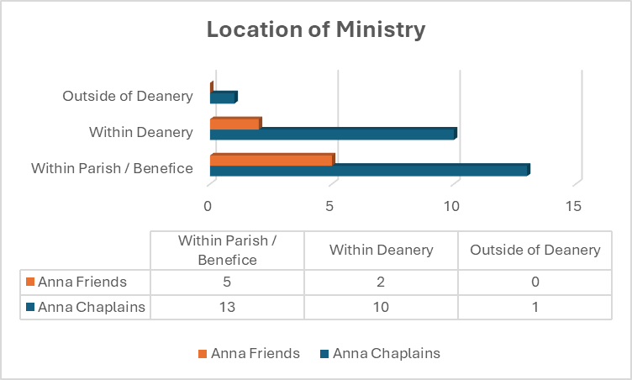

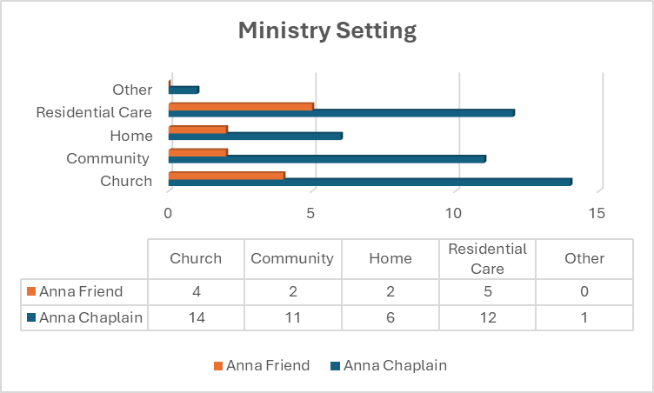

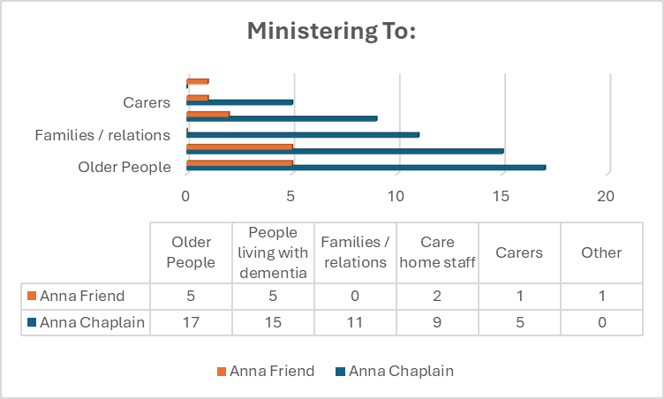

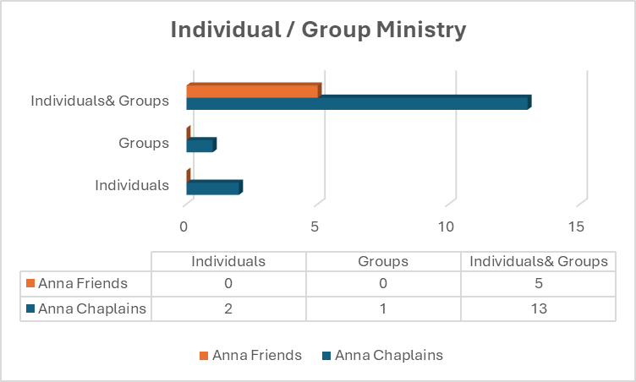

Anna Chaplains

Frequency of Anna Chaplaincy Ministry
- on average I am involved in something every day
- I visit Monday, Tuesday, Wednesday and Friday every week. I will only undertake funerals on Thursday as I try to keep a Thursday off. If I have another commitment on a visiting day, then I will visit the home I missed on that Thursday.
- A special monthly meeting and within warm space weekly
- 7 to 10 hours a week
- 4/5 days per week
- Weekly at least
- Monthly plus supervision of others
- Daily
- Two contact days per week. Prep time/training/teaching on other days.
- Each care home at least once a month more if requested. Individuals as requested"
- All the time
- As and when really, since my ordination in June, I have been especially involved with funerals, we seem to have a lot at present, and most of the people I have visited in this regard have been elderly. They have needed pastoral care but also help with practical tasks, so I have tried to combine my roles as curate and Anna Chaplain. One to one with older people who attend a weekly coffee morning and our monthly afternoon gathering, also attending sheltered housing combine monthly for worship.
- once a week in the local care home and once a week to do a variety of home visits. Once a month at a Church run cafe and once a month at a Memory Cafe run by Age UK"
- regular monthly visits to 3 Care Homes -plus individual visits as requested
- 1-2 days weekly, Saturdays, x3 hours in community cafe, Nursing home, x1month,1 1/2hour. Home visits ,2elderly ladies, x1month each,2hours

What brings you joy in your role?
- The smile when I go into a room - especially with one lady with dementia and another with Parkinson's. The singing in Singing for Wellbeing
- Everything! Last year residents, staff and family members took part in the 'Nativity' at Christmas and also the 'Easter Story' earlier this year. As you will guess, these were very challenging a day really stretched me.
- seeing people smile when they speak of their lives and what is happening in them
- It is a privilege and a pleasure to listen to people's stories as well as being attentive to their practical needs.
- Talking to people seeing their pleasure during services and generally talking and interacting
- Serving people who are often on the edge of society and church
- Engaging with people’s stories
- Being a listening ear. Always having to remind people how precious they are to our Lord Jesus Christ, what a privilege.
- Knowing that this ministry is worthwhile and important. Meeting new people and making many friends who are pleased to see me.
- Just to see how they all appreciate you being there, and some may ask you to pray for them. Their eyes light up and they are more attentive to both hymns and bible stories.
- Answering God’s call to give some support and comfort to older people. To bring a little light into their world especially when they are grieving.
- Being able to help in whatever ways are needed in the name of Christ
- Just coming alongside people, getting to know them and responding to their needs - often at moments that have surprised me and are God-directed. I am constantly amazed at what people will share of themselves and how God is in the sharing. I am aware that it is such a privilege - especially to be able to pray with people.
- Seeing the Care Home residents engage with reminders of the love of God we share - and their cheerful response to the Hymns we sing - with keyboard accompaniment and large print word sheets. Residents are also attentive to Bible readings, Poems and Prayers - often led by a Methodist Lay Minister who is also an Anna Chaplain. In one of the Care Homes, I also take Communion by Extension.
- I love being part of the weekly Holy Communion service in the care home. The smallest smile or eye contact with someone suffering from dementia fills my heart with joy.
- Making the difference, bringing the light

What do you find most challenging?
- Getting over being part of the "entertainment" in some residential settings
- I am challenged by one gentleman who verbally attacks me every time he sees me visiting the home.
- Grumpy people
- Finding the energy to deal with so many individuals' personal challenges in one day. It can be quite exhausting.
- Reaching those with advance dementia
- Severe dementia
- I try and engage with military veterans and use RBL and social club, but it is spasmodic
- Time
- Ensuring that senior staff in the homes appreciate what a ministry like this could do for the residents and for the home. Early days at the moment!
- Sometimes lack of interacting with the staff.
- Keeping to a sensible and workable time management strategy.
- Nothing comes to mind, except lack of time.
- Trying to establish a team of people to work alongside me. And the care home at the moment is not wanting other people to be independent visitors - i.e. anyone visiting the care home with me has to remain with me
- It is frustrating when Managers / Activity Managers leave, so that access has to be renegotiated. Many years ago, when churches were first invited (to tick the 'new' Spiritual Care box) these gatherings were limited to those who had stated they were Christians or Church goers of any denomination, so the gatherings were more intimate in smaller rooms. Gradually...over the years.... we are regarded as the Afternoon Entertainment, for everyone, spread around huge lounges. But they all like to sing the hymns! Another frustration is being unable to continue "Room Service" visits to individuals restricted to their rooms. This is because of Safeguarding and no member of staff being available to come with us.
- Getting contacts in the community
- Not having enough time

How would you like to develop your ministry over the next 6-12 months?
- Unsure - what I am doing is very fulfilling
- I will be attending a course regarding 'working with conflict.’
- Would very much like to start Messy Vintage Church, at least once.
- Perhaps by offering support/training on a deanery wide basis, but not taking the responsibility and ownership away from individual incumbents.
- Reach more people in care homes
- Easy access death and bereavement courses for me to train others in
- Have more concentrated time
- To be given support to grow my ministry
- Recruit Anna Friends and Anna Chaplains. I have run one Anna Friends course (just completed this week). Another course is set for October. Start good projects in the homes, building steadily over periods of time.
- How to make use of props, tactile items within a service.
- I would like to grow my group work to include bereaved and lonely folk as well as those suffering some degree of dementia. I also plan to take children into care homes at Christmas to perform a nativity. This will be in liaison with schools and of course parents.
- I hope to expand the work with the elderly we do now on a social level to include some form of worship, within the parish, not sure what form that might take yet.
- Finding people across my multi-parish benefice who would join me in the ministry - and establishing a team. Setting up a service for older people to follow on from our cafe"
- I would love to reach more people in the community.
- Improving, progressing in my ministry.

More details regarding Clergy Support
- As we are clergy, we are left to get on with it. No financial or spiritual support
- As in many churches across the Deanery most churches are presently without priests! In my own case I was commissioned in my parish, and it was the then incumbent who authorised me to continue the tradition of sharing Communion by Extension at just one of the Care Homes I am also Organist at a neighbouring parish which was (at that time) connected to my own parish. But I do try to take Second Sundays off when possible - to worship back in my own parish.

Do you feel supported by the Anna Chaplaincy Network?

100% of the Anna Chaplain respondents replied that they felt supported by the Anna Chaplaincy Network.

Any other comments
- Most of our dementia sufferers are in care homes, 90% of our parishioners are 80plus and most in their own homes. We have a Pastoral Friends group which were formed as part of our Mission Plan, and they work to hit another of the targets in the mission plan of Loneliness. I am too part of the Pastoral Friends team. The Intergeneration group is developing into a group in church and in care homes with children from the local CE Primary School (my priest and I are governors there) - this is where we do any craft etc. Singing for Wellbeing is wonderful - I take a lonely blind lady- 95 yrs old, a lady with Dementia and another 95-year-old. Other elderly people from the Parish get to the venue with carers or under their own steam. The talented leader just includes everyone.
- Sorry but just 1 concern. I have suffered with bad health over past 6 months (minor heart attack and a back operation); knowing I would be 'out of order', I spoke to my Area Dean and asked him to speak to the vicars at parishes where I minister to see whether someone from their pastoral teams or their selves could visit 1 nursing home each (3 homes in total) to take a Communion Service, once a month and to chat/listen/pray for staff and residents. I am now back ministering and have been told by staff at the 3 homes that nobody has visited them. I have 1 lady who visits 1 of the 6 homes with me but neither of us have been able to drum up helpers from other churches, either as 'Friends' or 'Chaplains'.
- What I can offer is limited my own and my husband’s ongoing health restrictions. Lack of stamina.
- We are on urgent need to expand the team esp. Anna Chaplains to cope with the pastoral demands and opportunities coming in via social prescribers
- Spiritual parish work in the community has only just started or is about to start. It will go alongside other secular organisations and dementia cafes. The hope is that the secular organizations will signpost us to those who ask about spiritual beliefs and faith.
- At the moment I am leading initiative, but we plan to encourage others to become Anna friends. We are just beginning to look at other ways to support those most in need.
- My parish does not include any care homes, so my ministry is limited I feel. when I join meetings where my colleagues report on their work in this area, I wonder if my ministry is enough,
- I have given a talk on Anna Chaplaincy at two Mothers Union groups in the Deanery to try and raise awareness. I feel stuck and a bit overwhelmed about how to encourage others to join me as a team.
- Thank you

Anna Friends

Frequency of Anna Friend Ministry
- monthly
- Hard to say as I see older people and talk with them every week, I'm in residential care homes twice a month
- Every week
- Weekly home church in a Residential home supporting the Anna Chaplin. 4/6weekly visits to individual clients that have moved into residential care setting outside of our parish.
- Almost every day sometimes two a day. Sometimes only say three a week.

What brings you joy in your role?
- seeing the responses of those I minister to
- Seeing people relax and smile and have a chance to meet with God
- Listening and chatting to folk
- That they are always pleased to see you and are humbled by their acceptance of their situation.
- Seeing the smiles when we arrive, sharing a good time with them as well the Word. Singing fellowship songs when doing messy vintage or singing the songs of their choice or doing quizzes for those who like quizzes. Being able to share our Lord with them and or giving them the opportunity to talk for as long as they need as often, they that although they like the activities we take for them they love to be able to talk saying it is a long day in the home. I also get great pleasure out of being Christ's hands and his feet. The Anna Chaplaincy l believe enables our parishioners to be supported when they ill or no longer able to get Church. This had always bothered me before Anna Chaplaincy. Also being able to support the bereaved. We also offer communion to our ex-parishioners. I love the work we do and long may it continue.

What do you find most challenging
- dementia
- Seeing people disappearing as dementia takes them
- People who can't speak
- When the services are interrupted by patients that are upset or disruptive. But we always cope and make something positive out of the situation.
- When those living with dementia are upset it is tough at times to see them having a bad day. Also, when they kick off with another resident. My Anna Chaplain is great at settling them and hopefully l will be able to too.

How would you like to develop your ministry over the next 6-12 months?
- be aware of new opportunities in newly opened care homes and expand home communions. Seeing other members of the congregation join our care home ministry.
- just to settle into what I'm doing
- Understand dementia more
- I am quite committed with what I am doing at the moment. To do individual residential care I am able to fit in when they arise, plus I am considering to bring an individual to our monthly singing for health session but haven't approached her about it yet as she has only just moved into care. With my other family commitments I feel this is all I can offer at the moment.
- I would dearly love to see more Anna Chaplains and Anna friends as my Chaplain is kept very busy. I am also praying that another Chaplain will start up a Messy Vintage group. She has a few members from Church at a friendship group once a month and she is trying to get teams together to run Messy Vintage at our Church.

Do you feel supported by your Anna Chaplain lead?

Yes | 4 | No | 0
Unsure | 1 | Rather not Say | 0

More detail on support by Anna Chaplain lead
- Not sure who my lead is

Do you feel supported by the Anna Chaplaincy Network
100% of the Anna Friend respondents felt supported by the Anna Chaplaincy Network

Are there any areas of training support that you would find beneficial?
- Dementia ministry and younger residents with severe learning difficulties
- Can't think of any
- Dementia.
- I feel that there is adequate networking and support there if I require it. I sometimes feel that I can't give it my full attention because of too much other goings on in life. But I do what I can even though I sometimes feel it’s not enough.
- Bereavement, dementia

Any other comments
- I feel privileged to have been given this ministry.
- I thoroughly enjoy what I do in supporting the Anna Chaplin. I know the importance of the meet up zoom meetings and seeing everyone, but I do not enjoy them, possibly too long and late.
- There seems to be a problem with some churches being precious over their parishes. I think it is such a shame that they don't do anything for their parishioners in care homes yet will not let Anna Chaplains take Messy Vintage into them.
Parish Provision for Older People and Dementia Ministry

Does your parish have a named contact for older people / dementia ministry?
Ten out of the seventeen Anna Chaplains responded to say that they have a joint contact for dementia and older people ministry.

CAMEO – Come and Meet Each Other

* Congregational awareness, accessible buildings, signage…
** Large font orders of service, familiar hymns etc

