
Toolkit for Parishes

Introduction
We are inviting every parish to join in a renewed commitment to God’s mission.
This document is a toolkit of ideas designed to help your parish and deanery discern the focus of three things for mission in your community.

Ministry with Children and Young People
Our Children, Young People and Schools Framework offer a comprehensive programme of support to help every church develop their work, whether starting from scratch or already well-established.
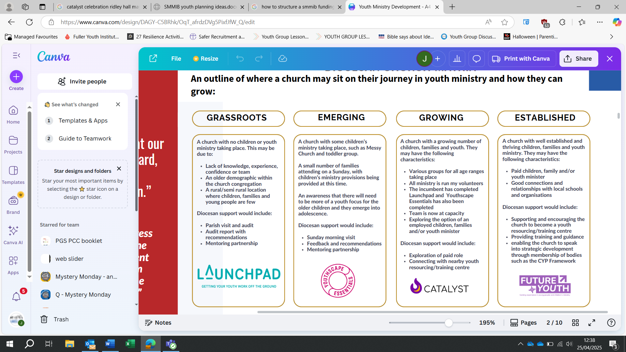
To learn more about this programme, please contact Jen Tobin, our Lead Officer for Children and Young People Ministry. Additional resources are available on the CYP webpage on our website.

Partnering with Schools
Building strong partnerships with schools can deepen relationships, offer pastoral support, and introduce faith in accessible ways. Here are some ways to get involved:
- Chaplaincy-style presence: Appoint lay or ordained volunteers to regularly visit schools, offering pastoral care and spiritual support to children, families, and staff.
- Shared events: Host seasonal services (Harvest, Christmas, Easter, Remembrance) in school halls or churches, co-designed with pupils and staff.
- Faith & values curriculum support: Offer input on RE lessons, assemblies, or themed weeks (e.g. “Hope,” “Justice,” “Forgiveness”).
- Prayer spaces: Create interactive prayer stations in schools during Lent or Advent.
- Youth-led worship: Invite pupils to co-lead occasional Sunday services or Messy Church-style gatherings.
- New worshipping communities: Consider working with schools for new opportunities such as Messy or Café Church. FLOURISH partnerships between schools and churches can also create new communities.
- Volunteers making a difference: Volunteers getting involved with Open the Book or supporting breakfast, lunchtime, or after-school clubs not only help the school but build relationships that faith can build on.
- School Governors: Lay or ordained people being foundation governors in church schools or being elected or appointed as community school governors can make a huge difference in supporting schools and their young people.

Building Mission
- Leading your Church into Growth (LyCiG): A two-day conference and ongoing process for church leaders to introduce and establish church growth principles.
- Growing Confidence in the Parish
- Noticing and Naming: Practices for everyday faith, encouraging confidence in talking about faith.
- Teaching and Learning Resources: There are many courses to help Christians speak about their faith more confidently, for example, the Church Army’s Faith Pictures.
- Deepening Discipleship: A course run by our diocese and available to every parish.

Resourcing the Local Church
- Generous Giving: Promoting giving and generosity to fund future mission and growth.
- Parish Giving Scheme: A Direct Debit scheme for churches, making it easy for people to give and increase their giving.
- Diocesan Advisory Committee (DAC): Support for PCCs with advice on maintenance, repairs, and improvements to church buildings.
- Buildings for Mission: Helping churches with maintenance issues, grant applications, and community outreach.
- Archdeacons: Able to advise on how to do things differently:
  - Where to concentrate initial efforts in multi-church settings
  - What doesn’t have to be done, so you can concentrate on what you need to
  - Governance – what can you do differently

Developing Formal Ministry
- The Canterbury Diet for (Lay) Ministries: A framework for good practice in lay ministry.
- Development, training, and formation for Lay Ministers: Courses, workshops, and networking opportunities for lay ministers.
- Dover Pathway: A route to ordination for those over 65 years old with an established track record of leadership and ministry.

Doing Church Differently
Across our Diocese and the Church of England, there are different models of worship or being the church that might make a difference in your context:
- Ignite: Ignite is church, but probably not as most people know it. This café-style church is for people who may not feel comfortable in a traditional church service. It is designed and tested to work particularly well with people living in our marginalised and social deprived communities. “We love because God first loved us" (1 John 4:19). We love people, with no agenda, because God first loved us.
- Renew Wellbeing: Renew spaces are simple cafe style spaces run by local churches where hobbies and activities are shared or co-produced. Each cafe space is attached to a quiet room or prayer space where inner habits of wellbeing are shared. Each church partners with a mental health professional from the local council or other suitable organisation to ensure good inclusive practices for safe spaces where it's OK not to be OK can be sustained.
- Messy Church and Café Church: These are well tried and tested models that can make a real difference. Messy Church is officially an initiative of the Bible Reading Fellowship (BRF). Visit the BRF website for more information.
- Focal Ministry: This could also sit in the Developing Formal Ministry section but it’s really about how we do leadership differently in the local church where one priest is looking after a number of churches. The Focal Minister works alongside the local incumbent or priest-in-charge. The position refers to a local leader, whether clergy or lay, who represents the church within their community. In this capacity, focal leaders emphasise growth, mission, and discipleship in the activities of the church.
- Church planting or grafting: This is different to planting a new Christian community in your own parish! Some churches have enough resources to plant a new church somewhere where the church isn’t well represented or graft (that’s send people to join and strengthen another church). If your church is looking to plant or graft, it’s worth having a chat with your archdeacon. You may be a parish that would like to invite a church to plant or graft with you. Again, have a word with your archdeacon to explore this more.

12/09/2025 Diocese of Canterbury

