Canterbury Diocese
Deanery Roadshows 2023
‘The kingdom of heaven is like a mustard seed that someone took and sowed in his field; it is the smallest of all the seeds, but when it has grown it is the greatest of shrubs and becomes a tree, so that the birds of the air come and make nests in its branches.’
‘The kingdom of heaven is like yeast that a woman took and mixed in with three measures of flour until all of it was leavened.’ (Matthew 13:31-33)

Three Bold Outcomes for 2030
- Double the number of children and young people
- 200 new Christian communities
- Every parish, benefice and deanery showing signs of revitalisation.

Three Questions for your church and PCC
- How will you increase the number of children and young people in your parish?

- What sort of new worshipping community will you create, and how will you do this?

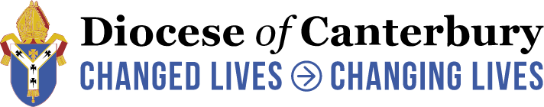
- What does new life look like in your church?

