Collective Worship resources
Theme: Christmas

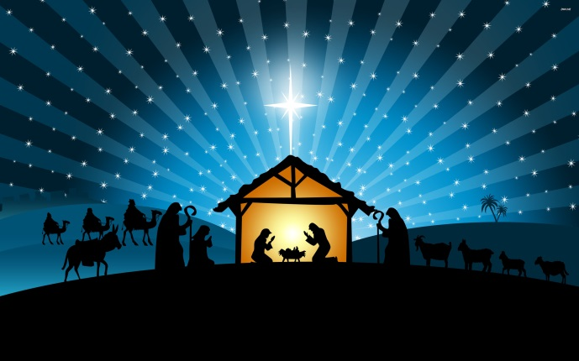

The nativity of Jesus or birth of Jesus is described in the gospels of Luke and Matthew. The two accounts agree that Jesus was born in Bethlehem in the time of Herod the Great, that his mother Mary was married to Joseph, who was of Davidic descent and was not his biological father, and that his birth was affected by divine intervention, but the two gospels agree on little else. Matthew does not mention the census, annunciation to the shepherds or presentation in the Temple, and does not give the name of the angel that appeared to Joseph to foretell the birth. In Luke there is no mention of Magi, no flight into Egypt, or Massacre of the Innocents, and the angel who announces the coming birth to Mary is named (as Gabriel).
In Christian theology the nativity marks the birth of Jesus in fulfillment of the divine will of God, to save the world from sin.
The Bible Society have produced some great resources to support the telling of the Christmas story with schools.
https://www.biblesociety.org.uk/get-involved/christmas/
Our new children’s story, The Mystery of the New Noisy Neighbour, places a mouse detective at the heart of the action – and he slowly discovers who Jesus really is… Emmanuel, Rescuer and King.
https://www.youtube.com/watch?v=URMtYSvMJys

Bible story videos:
https://www.youtube.com/watch?v=FrOBJo6LNfw – God’s Story, Jesus is born
https://www.youtube.com/watch?v=nk58bHnJLD4 – God’s story, Christmas
https://www.youtube.com/watch?v=67HqiVGt6xI – God’s Story, preparing for Jesus

https://www.barnabasinschools.org.uk/idea/episode-1-angel-gabriel-visits-mary-paperlesschristmas Paperless Christmas videos, modern retelling of the Christmas story.

Christmas videos:
https://www.youtube.com/watch?v=TM1XusYVqNY – Unexpected Christmas

https://www.youtube.com/watch?v=2sO3InyiIjw – Retuning Christmas, do we really know the story?

https://www.youtube.com/watch?v=FYh2OU4vtIk – Bethlehem Rhapsody. A retelling of the Christmas story to the tune of Bohemian Rhapsody. Well worth a watch!

https://www.youtube.com/watch?v=f7baFMmSv4k – Christmas story flash mob. Watch to the end for a emotive finish.

https://www.youtube.com/watch?v=7B7IvtELiZs&list=PLZwsEkJqiv-Zx_Bk3SxUwDdZZLdh1vZSF
Nativity Story Birth to Cross Line Drawing

https://www.youtube.com/watch?v=mNbSgMEZ_Tw John Lewis Christmas Advert 2018

https://www.youtube.com/watch?v=KoxTF_31yyE – John Lewis Advert remake 2015 – God gives the world a gift.

https://www.youtube.com/watch?v=MOByXwK-g94 - Christmas begins with a babies giggle – real meaning of Christmas

https://www.youtube.com/watch?v=kuRn2S7iPNU – Sainsbury’s Christmas advert – Mog’s calamity, importance of sharing what we have with others.

Songs to listen to:

https://www.youtube.com/watch?v=qu5RY94ldDc&index=4&list=PLedV3ijsZ39wLGZezuuPoIbBvjvUR87Zf – Piano Guys We three Kings.
https://www.youtube.com/watch?v=JkTd4pJlT-E&list=PLedV3ijsZ39wLGZezuuPoIbBvjvUR87Zf&index=5 – Piano Guys Rudolf the Red Nose Reindeer, funny!

https://www.youtube.com/watch?v=n543eKIdbUI&list=PLedV3ijsZ39wLGZezuuPoIbBvjvUR87Zf – Piano guys Angels we have heard on high.

https://www.youtube.com/watch?v=pFjdfjrtf1Q – Pentatonix That’s Christmas to me.
https://www.youtube.com/watch?v=Mj7Pr42rliI Pentatonix O Come All Ye Faithful

https://www.youtube.com/watch?v=y4U2pGgrsC0 – Christmas Hallelujah

https://www.youtube.com/watch?v=hN9342aVZiY – When I think upon Christmas, Hillsong

Songs to sing:

https://www.youtube.com/watch?v=V0h-Qjiyc24 – O what a Glorious night
https://www.youtube.com/watch?v=6aGLV5CfoTU

https://www.youtube.com/watch?v=mWz2X_h72nU – Sweet Bells by Kate Rushby
https://www.lyricsmania.com/sweet_bells_lyrics_kate_rusby.html - Lyrics for Sweet bells.

https://www.youtube.com/watch?v=lSdq90fJX6M – Tell the World by Push Community

https://www.youtube.com/watch?v=cSLrFVR-Hqw – Born is the King, Hillsong

Other Christmas acts of worship:

https://www.assemblies.org.uk/search.php?term=Christmas&ksval=6&order=aid&offset=0&restype=part (Ensure they are written for Church of England schools)

https://www.barnabasinschools.org.uk/topics/christmas

The Christmas Story in the Bible
Old Testament – Prophesied | New Testament – Fulfilled

Born in Bethlehem
Micah 5:2 But you, O Bethlehem Ephrathah, who are too little to be among the clans of Judah, from you shall come forth for me one who is to be ruler in Israel, whose coming forth is from of old, from ancient days. | Luke 2:4-7 And Joseph also went up from Galilee, from the town of Nazareth, to Judea, to the city of David, which is called Bethlehem, because he was of the house and lineage of David, to be registered with Mary, his betrothed, who was with child. And while they were there, the time came for her to give birth. And she gave birth to her firstborn son and wrapped him in swaddling cloths and laid him in a manger, because there was no place for them in the inn

Jesus, The Son of God
Proverbs 30:4 Who has ascended to heaven and come down? Who has gathered the wind in his fists? Who has wrapped up the waters in a garment? Who has established all the ends of the earth? What is his name, and what is his son’s name? Surely you know! | Luke 1:31-33 “…And behold, you will conceive in your womb and bear a son, and you shall call his name Jesus. He will be great and will be called the Son of the Most High. And the Lord God will give to him the throne of his father David, and he will reign over the house of Jacob forever, and of his kingdom there will be no end.”

Jesus, Name Above All Names
Isaiah 9:6 For to us a child is born, to us a son is given; and the government shall be upon his shoulder, and his name shall be called Wonderful Counselor, Mighty God, Everlasting Father, Prince of Peace. | Philippians 2:9-11 Therefore God has highly exalted him and bestowed on him the name that is above every name, so that at the name of Jesus every knee should bow, in heaven and on earth and under the earth, and every tongue confess that Jesus Christ is Lord, to the glory of God the Father.

Jesus, The Anointed One
Daniel 9:25-26 Know therefore and understand that from the going out of the word to restore and build Jerusalem to the coming of an anointed one, a prince, there shall be seven weeks. Then for sixty-two weeks it shall be built again with squares and moat, but in a troubled time. And after the sixty-two weeks, an anointed one shall be cut off and shall have nothing. And the people of the prince who is to come shall destroy the city and the sanctuary. Its end shall come with a flood, and to the end there shall be war. Desolations are decreed. | Matthew 2:1,16 Now after Jesus was born in Bethlehem of Judea in the days of Herod the king, behold, wise men from the east came to Jerusalem … Then Herod, when he saw that he had been tricked by the wise men, became furious, and he sent and killed all the male children in Bethlehem and in all that region who were two years old or under, according to the time that he had ascertained from the wise men.

Jesus, Born of a Virgin
Isaiah 7:14 Therefore the Lord himself will give you a sign. Behold, the virgin shall conceive and bear a son, and shall call his name Immanuel. | Matthew 1:21-23 She will bear a son, and you shall call his name Jesus, for he will save his people from their sins.” All this took place to fulfill what the Lord had spoken by the prophet: “Behold, the virgin shall conceive and bear a son, and they shall call his name Immanuel” (which means, God with us).

Jesus, Seed of Abraham
Genesis 12:3 I will bless those who bless you, and him who dishonors you I will curse, and in you all the families of the earth shall be blessed.” | Matthew 1:1 The book of the genealogy of Jesus Christ, the son of David, the son of Abraham.

