Collective Worship resources
Theme: Advent

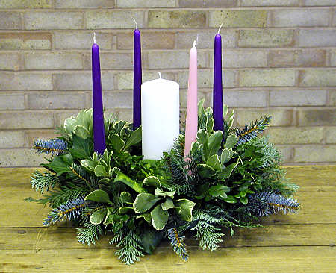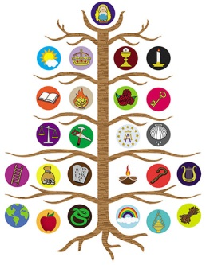
https://realhomilies.files.wordpress.com/2011/11/advent_wreath.jpg https://www.autom.com/product/jesse-tree-magnet-set-6-sets-pk-YC306/sacramental-and-seasonal https://worshiphousemedia.s3.amazonaws.com/images/main/s/mo/ima/mo/maryandjosephsjourney.jpg
Advent is a very special time of year in the Christian calendar. It is a time of preparation, of expectation and waiting, a journey, and an invitation to engage with the mystery of Christmas.
The season of Advent is celebrated in churches during the four Sundays before Christmas. There are many different ways of marking this season in schools and, although this is a busy and exciting time of year, it is important to allow time during collective worship for adults and children to pause and reflect, to relax and breathe. It is suggested that you allocate about two weeks of collective worship time to Advent, recognising that one day will be singing/psalm worship and one day celebration worship.
Advent is full of symbolism and tradition. Your local church will have their own traditions and is likely to be happy to visit and share these with the children. Your school may already have a strong set of Advent practices in place. The following ideas are offered as a menu of suggestions to enhance your existing ideas during this time.

Advent Wreath

You will need a ring of florists foam, some sprigs of evergreen foliage, five candles (preferably 4 purple and 1 white. Some people like to use a pink candle on the third Sunday).
The significance of the evergreen wreath as a symbol of God’s eternal and everlasting love should be explained. The fifth candle is lit for Christmas and represents Jesus as the light of the world.
There are several ways you can introduce each candle. You could use a different set of explanations each year. e.g.
Year 1 | Year 2 | Year 3
Patriarchs | Hope | Prophets
Prophets | Love | Mary and Joseph
Mary | Joy | Shepherds
John the Baptist | Peace | Kings

Jesse Tree
https://www.whychristmas.com/customs/jessetrees.shtml
For each collective worship during Advent hang a new ornament on the tree and tell the story of Jesus’ family tree.
Las Posadas (Scholastic.com)
Posada is the Spanish word for inn and is used in reference to Mary and Joseph’s journey to find room in an inn for the birth of baby Jesus. Many families in Mexico and the United States remember this occasion by re-enacting the pilgrimage as they go door to door throughout their neighbourhoods asking their friends and neighbours if they have room for the Holy Family. Participants may dress like Mary and Joseph or carry statues from their nativity scenes (nacimientos) as they walk, candles in hand, singing a traditional Posada song requesting entrance. The first houses visited always turn away the travellers, saying they have no room. Finally, upon reaching the last house, all are welcomed in for a festive celebration, complete with food, music, and a piñata. This practice is repeated nightly for the nine days leading up to Christmas (December 16–24).
During Advent have a child-friendly Nativity set visit classes. The Nativity set comes back into worship every day before being given to the next class. It is fun to include all the areas of the school including the office and kitchen.
https://www.scholastic.com/teachers/blog-posts/amanda-nehring/las-posadas-cultural-christmas-classroom/
https://teachables.scholastic.com/teachables/books/The-Story-of-Las-Posadas-9780439073455_023.html (available for free if registered)

The Twelve Days of Christmas
https://www.achievebalance.com/think/12days.htm
There is (possibly!) a hidden meaning to this well-known Christmas song! The story goes that in 16th century England Roman Catholics were forbidden to teach their faith to their children so they disguised their teaching using metaphors and taught them the song “The Twelve Days of Christmas”. This is great fun to use through Advent. You could use a power point presentation or add to a display as the days go on. It is suggested you go through two ‘days’ each collective worship.
(The singer of the carol is the ordinary person who believes in Christ, and his 'true love' is God the Father. The accumulative pattern of going back each time through all the verses teaches the ongoing and abundant blessings of a loving God. We repeat to help us not forget what we have received. The whole song is a joyful celebration of what God has done for us.)
- The partridge, a bird reputed to choose death to defend its young, is an ancient Christian symbol of Christ. Certainly one can see how Jesus' sacrifice was a gift to the world.
- The two turtledoves signify the sacrifice offered in the temple by Joseph and Mary at the presentation of the Christ-child in the temple. (Some say that these two are actually the two testaments, Old and New, that were given by God.)
- The three 'French hens', priceless poultry in Elizabethan England, represent the three valuable gifts of the Magi. (Elsewhere I have seen that the three French Hens represent the three best things: Faith, Hope and Love.)
- The four 'calling birds' are the Gospel writers, Matthew, Mark, Luke and John.
- The five 'golden rings' represent the Jewish Torah – the first five books of the Bible: Genesis, Exodus, Leviticus, Numbers, Deuteronomy.
- The six 'geese a-laying' represent the six days of creation.
- The seven 'swans a-swimming' are the seven gifts of the Holy Spirit. (Corinthians 12:9-11, Romans 12, Ephesians 4, 1 Peter 4:10-11)
- The eight 'maids a-milking' are the Beatitudes (Matthew 5:3-11)
- The nine 'ladies dancing' could refer to the nine choirs of angels. Some say that these represent the nine fruits of the Holy Spirit. (Galatians 5:22-23)
- The ten 'lords a-leaping' are the Ten Commandments. (Exodus 20)
- The eleven 'pipers piping' signify the 11 Apostles, who proclaimed the resurrection.
- The twelve 'drummers drumming' are the twelve beliefs in the Apostles' Creed.

