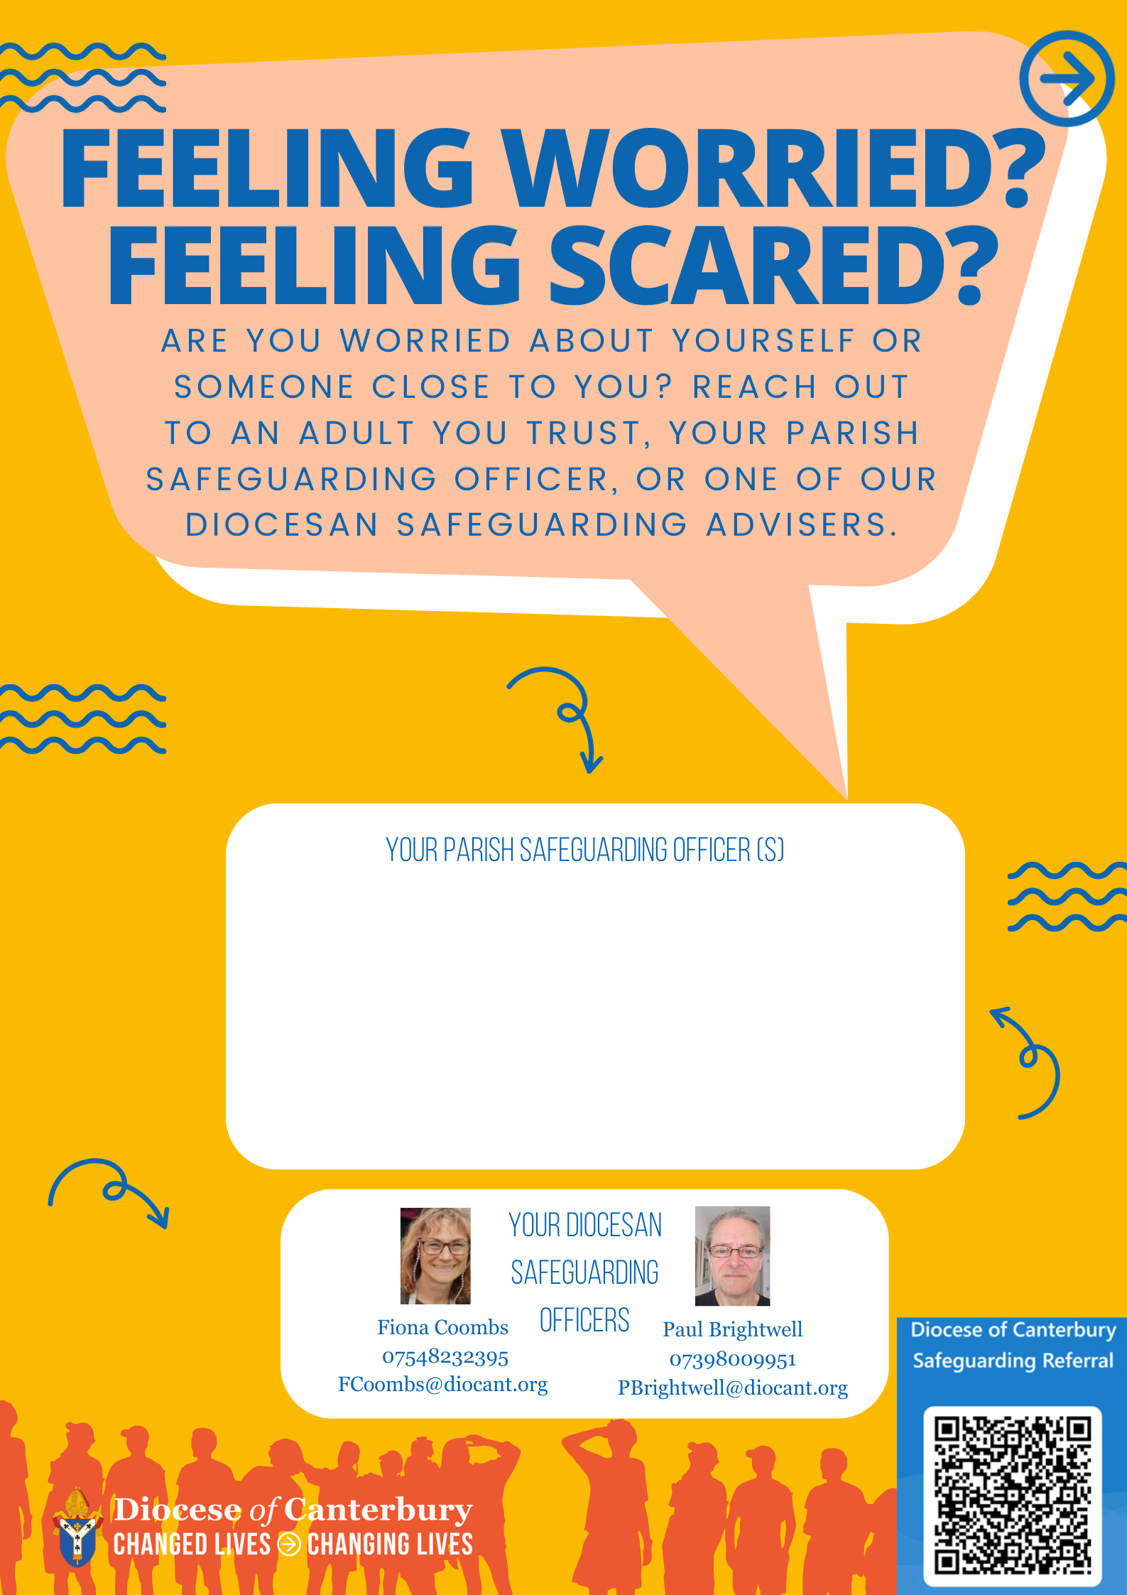

Officer contact details

Officer contact details

Parish safeguarding officer photo 2

Parish safeguarding officer photo 1