Fresh Approach Collective Worship Planning
Year 3 Term 3: Good News

Week 1 | Epiphany - what can we offer?  Although there are often Wise Men in the stable on our Christmas cards, the Church traditionally marks the visit of these travellers from the East on Epiphany (6 January). Their journey, once they saw the star, would probably have taken many months.
Week 2 | The four gospels
Week 3 | Gospel – Jesus brings good news
Week 4 | Gospel - Jesus brings good news
Week 5 | Gospel – Jesus brings good news
Week 6 | Lent (starts on 14/2/24 during half term)  In 2024, Lent starts on Wednesday 14 February so it seems most logical to look at Lent before it starts as pupils might have their pancakes during half term.
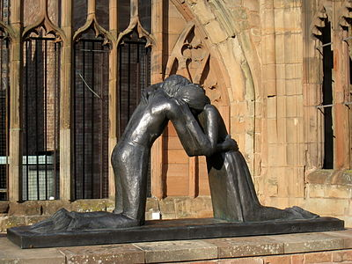

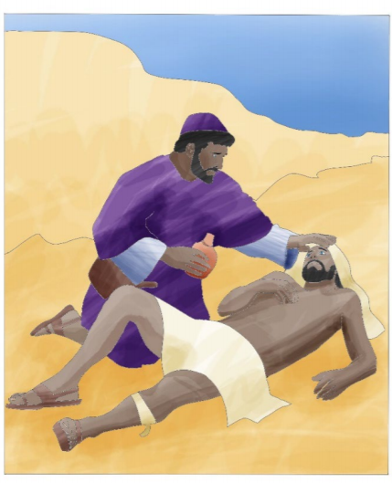
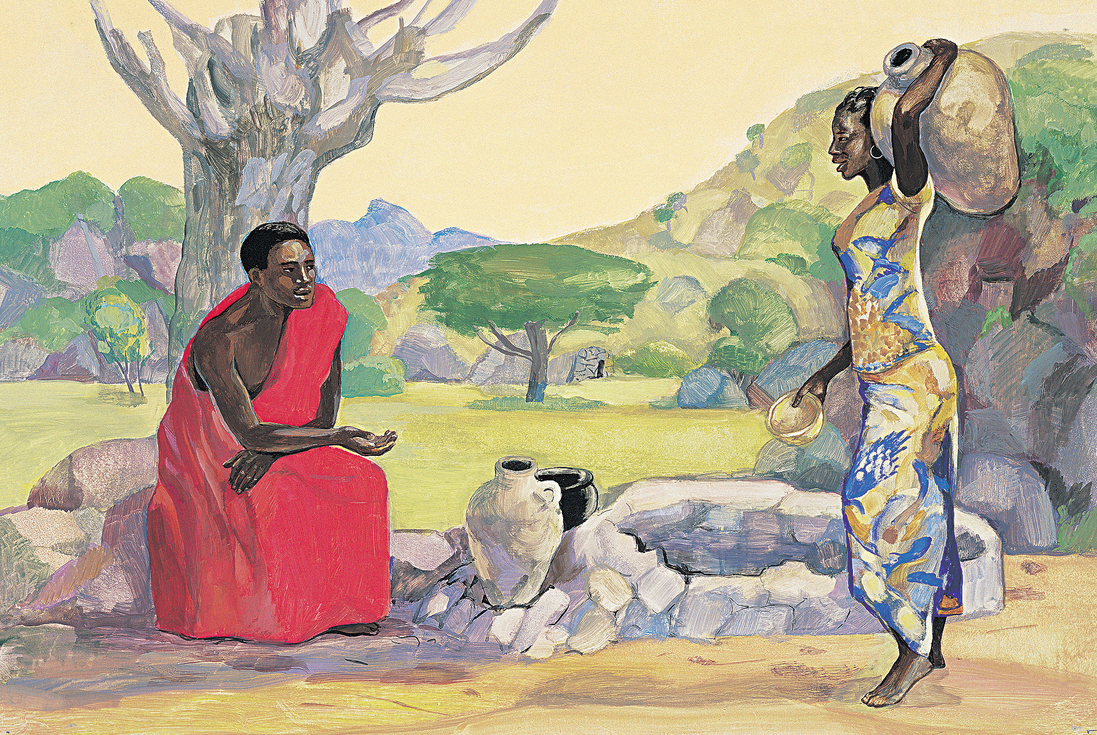
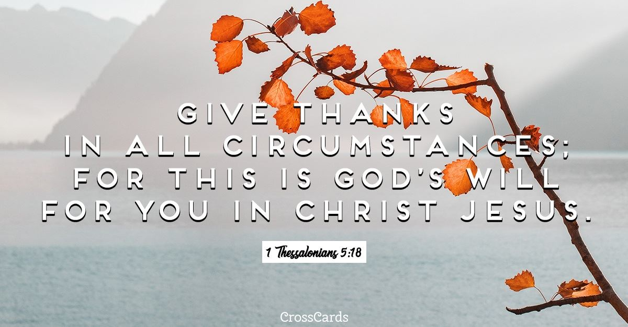
This term, we move onto looking at the life of Jesus – your Understanding Christianity big frieze might help you to link ideas explored in collective worship and RE in appropriate ways. The concepts visited this term will be:
- Incarnation (Epiphany)
- Gospel (the life of Jesus)
Remember that the success of an act of worship lies in a simple message which is age appropriate. Select the idea or ideas from the suggestions each day that will help you to do this for your group with their particular needs in your specific context. This includes the clips and web suggestions – make sure that you have watched them and that they will work for your school community.

Liturgical colour | Monday  Whole School | Tuesday  Whole School | Wednesday  Whole School | Thursday  Worship in the classroom | Friday  Celebration worship
Week 1  For | THE WISE MEN OFFER WORSHIP  Matthew 2 v 1-12  I wonder if you have ever received an invitation or sent one. Look at a range of invitations – wedding, birthday, supermarket double points, join a gym etc. Use a star shape – say that there is an invitation on the back – I wonder who this is for/what this invitation says. This star in the sky was an important invitation and, although everyone could see it, only the Wise Men realised what it meant. They accepted the invitation of the star even though it meant a very long journey. The invitation of the star was to come and worship Jesus, the gift of God to the world.  Different ways of telling the story – both reflect that the visit was probably up to 2 years after Jesus was born (not in the stable with the shepherds!)  https://www.youtube.com/watch?v=eQGPyLA7gcQ  https://www.youtube.com/watch?v=22SMUUMsx0o&t=5s  Alternatively use an appropriate Bible version with images  I wonder how we are invited to worship in school. In doing so, we are responding to the same invitation as was sent to the Wise Men so long ago to bring our gifts of worship.  We will think more about the actual gifts of the Wise Men later in the week.  You could make a display of a treasure box for each class or for a common area and invite pupils to add their gift to Jesus to this display as a prayer – focus on gifts that do not cost anything (their gifts, talents, time etc) | THE WISE MEN OFFER GIFTS  Matthew 2 v 1-12  Some background information might help : https://www.whychristmas.com/story/wisemen.shtml  Look at some pictures of the wise men as painted by great artists.  Search ‘Adoration of the Magi’ and the National Gallery website  https://www.nationalgallery.org.uk/podcast/podcasts/the-national-gallery-podcast-episode-86  https://www.nationalgallery.org.uk/paintings/sandro-botticelli-the-adoration-of-the-kings  https://www.nationalgallery.org.uk/paintings/gerard-david-adoration-of-the-kings  Ask pupils:  I wonder what you can see in this picture.  I wonder what you like about this picture.  I wonder why the Wise Men are wearing crowns. (if they are)  I wonder why artists show the Wise Men visiting the stable when it would have taken them many months to reach their destination.  I wonder who is the most important person in this picture.  The Wise Men represent the Gentiles, those from the whole world for whom Jesus has come into the world and to whom the good news of Jesus will be taken following his life on earth, his death and resurrection.  Pray for our world – think about situations in the news today and ask for God’s help, love and blessings for those experiencing difficulties or worries around the world. | THE WISE MEN OFFER BLESSINGS  Matthew 2 v 11  The bringing of precious and symbolic gifts by the Wise Men means that in certain countries and cultures around the world, the celebration of the visit of the Wise Men is the most important part of Christmas celebrations and is the focus for this season. I wonder what you would include if you were designing a Three Kings Day (as it is called in certain countries).  I wonder if that is actually what happens around the world. See information: https://www.whychristmas.com/customs/epiphany.shtml  Use age-appropriate clips or find images to explore the celebrations further:  https://www.youtube.com/watch?v=P3zXE3NNc5U (presents)  https://www.youtube.com/watch?v=OKhsjj58Cv4 (parade in Madrid)  https://www.youtube.com/watch?v=5yu5LhOvjz8 (Three Kings cake)  https://www.youtube.com/watch?v=kqq-xMA76Hk (questions and answers for older pupils)  https://www.youtube.com/watch?v=NHrohZPLyY0 up to 1:20 (how traditions move across the world)  We 3 Kings carol – different styles  https://www.youtube.com/watch?v=jBwL3y-Wlms  https://www.youtube.com/watch?v=68k6dzdzoto&t=13s  Pray that those celebrating Three Kings Day across the world will experience the joy and peace of Christmas today. | THE IMPORTANCE OF A GIFT  Matthew 2 v 11  I wonder what gifts you gave for Christmas. I wonder if your choice was because the person would like those gifts or because they would suit the other person.  You might want to unwrap some things that represent gold, frankincense and myrrh. The Wise Men chose gifts for Jesus that suited him and which told the world what sort of person he was going to be – a new sort of King (gold), a new sort of Priest (frankincense) and someone who would have a new sort of death (myrrh). You might want to focus on particular gifts here depending on the age of the pupils.  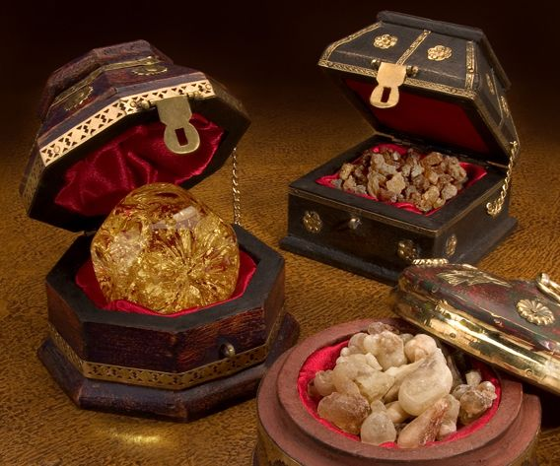  Find images of the gifts or the real thing.  Use a clear bowl containing water. Have one white or gold floating candle ready on the water. Encourage the children to be still and quiet, as you get ready for the prayer time, then light the candle (safely for all)  Dear God, the Wise Men knew that Jesus was special. Help us to remember that we can make Jesus special in our lives, too. Amen  Leave a moment of quiet before blowing out the candles | CELEBRATE  I Peter 4 v 10  If you have used the idea suggested on Tuesday, offer and share some of these ideas.  In the bleak midwinter asks ‘what can I give him (Jesus)?’ – from 2 mins  https://www.youtube.com/watch?v=zZYrg8468XY  Use the words of this carol as a reflection as you celebrate the ‘gifts’ that are given and receive in your school day by day  What can I give Him,  Poor as I am?  If I were a shepherd  I would bring a lamb,  If I were a wise man  I would do my part,  Yet what I can I give Him,  Give my heart.  I wonder what gifts we are going to offer and share with others in school today.
Week 2 | THE GOSPEL OF MATTHEW  Simon - Matthew 16:16  I wonder how we know all that we do about Jesus and what he did whilst he lived. We have 4 books in the New Testament of the Bible called gospels written by 4 different authors who tell us about what Jesus did and what he taught. I wonder what ‘Gospel’ means. (you may have talked about this is your RE lessons). This week we are going to meet 4 people, each one from a different gospel – the gospels help us to meet the people that Jesus met and to see how they changed or were challenged as a result.  https://www.youtube.com/watch?v=poNuGusSX5c  based on Matthew 4:18-20  I wonder what sort of person Simon was when he first met Jesus. I wonder how and why he changed.  Read Matthew 16:16 – here Jesus gave Simon a nickname. I wonder why he chose the name, Peter the rock. Sometimes that rock was a real support and sometimes it was very wobbly! – for example, when Peter said he did not even know Jesus.  https://www.youtube.com/watch?v=jRzL1Aca4Lw  based on Matthew 26:69-75  I wonder what we can learn from our meeting with Simon Peter in the gospel of Matthew. Perhaps it is that God knows the best you can be and wants to help you to become that.  Dear God, When I am feeling sad or disappointed in myself, help me to remember that you are there to forgive me and to be with me as I go forward with you by my side. AMEN  https://www.youtube.com/watch?v=xznM-v8fkYI  Song and images reflecting the life of Simon Peter | THE GOSPEL OF MARK  Trick Questioners - Mark 12:13-17  I wonder if you have ever been asked a ‘trick question’. I wonder what it was like to feel that someone was trying to catch you out.  There are some examples here:  https://thoughtcatalog.com/january-nelson/2018/03/65-riddles-for-kids-guaranteed-to-stump-you-too/  Sometimes Jesus met people who tried to catch him out with trick questions to try and make him look as though he was not who he said he was – that he was not God’s Son. I wonder what most people might do if they were being ‘caught out’ or made to look a bit foolish.  Read the episode from the gospel of Mark or watch  https://www.youtube.com/watch?v=cKvJVEafDBk  I wonder why Jesus’ answer to the question was a wise one. These questioners tried to trap Jesus by asking about the payment of taxes. Jesus looked behind the questions to what people were really saying.  I wonder what we do if someone tries to catch us out or make us look foolish or bad. I wonder how we can try and answer calmly and wisely.  Think of a prayer or reflection acrostic like this one. | THE GOSPEL OF LUKE  Martha - Luke 10:38-42  I wonder if anyone has ever said that they are ‘too busy’ and asked you to go away. I wonder if you have ever said that to another person. I wonder how that made you feel. I wonder how that made them feel.  Here is an episode from the gospel of Luke where that happened – it is a good one to dramatise and then discuss.  Also, these might be appropriate for certain ages:  https://www.youtube.com/watch?v=C91ygWW2u0U  https://www.youtube.com/watch?v=IAt3xm-iIFs  https://www.youtube.com/watch?v=jiB6ySr5PNI  I wonder what you would have done. I wonder if you would have been like Martha or like Mary. I wonder if you feel sympathy for Martha. I wonder what you think about Mary. Martha often gets a bad press but she was only trying to be a good hostess. We are all different sorts of people and it seems that Martha and Mary each welcomed Jesus in their own special way.  I wonder what sort of welcome we give to visitors to our school, to our classrooms, to our games in the playground. I wonder whether we could improve our welcome and share our time better with others.  A prayer of Teresa of Calcutta  Jesus, Shine through me and be so in me that every soul I come into contact with may feel your presence in my soul. | THE GOSPEL OF JOHN  Philip and Nathanael  John 1:43-50  I wonder what you think are the best qualities of friendship and why we choose the friends we have. I wonder if your friends are like you or unlike you.  You could act out the story of Philip and Nathanael. Props to help tell this story could include: some fig leaves; a ladder, acting out of Philip's enthusiasm and Nathanael's grumpy response.  Possible clips:  https://www.youtube.com/watch?v=9j5CPuAUCAg (younger – very USA)  Nathanael and Philip were the best of friends - but they were very different. That's sometimes the way with best friends. It is sometimes even what makes people best friends. Philip was always on the go: an action-packed sort of man, not one for sitting around. He had things to do, people to meet, practical problems to solve. Nathanael, in contrast, was a quieter sort and more thoughtful. He was much more likely to be sitting around and thinking. He paused before he spoke and spoke before he acted. Nat took things slowly. I wonder, are you like more like a Philip or more like a Nathanael.  Spend time saying thank you for all the different things that help you get along well with others in your class and school. | CELEBRATE  Mark 1:1-2  The gospel of Mark starts with ‘shouting out’ the good news about the Jesus Christ, the Son of God. This week, we have looked at the Gospel (Good News) through people that Jesus met in the 4 gospels written by Matthew, Mark, Luke and John.  I wonder what good news you can share and celebrate from your week in school.  I wonder what good news you can be thankful for in the world this week.  I Thessalonians 5:18
Week 3 | WHAT IS THE GOOD NEWS (GOSPEL) THAT JESUS BRINGS?  Luke 10: 25-37  We are going to continue to look at Jesus’ life and teaching in the gospels which encapsulates the Gospel. I wonder what Jesus taught about embracing difference and helping everyone to belong. I wonder who you think is your ‘neighbour’.  Explore the story of the Good Samaritan  https://www.bbc.co.uk/teach/class-clips-video/treasure-champs-10-empathy-the-good-samaritan/z3p7xbk  (BBC clip - updated)  Free bible images offers a series of pictures for telling the parable.  I wonder why some people simply ignored the man lying injured. I wonder if we ever ignore situations that need our help and understanding.  During the time of Jesus, people believed Samaritans were people to be avoided. They were seen as different and not as important and so people tried to stay away from them. They didn’t belong. That is why it is so surprising that it is not the priest or the Levite that stops to help the injured man, but a Samaritan! The first two men – the ones who did belong - could have helped, but they let their prejudice get in the way of doing the right thing. After listening to the story, the questioner has to accept that it is a Samaritan who takes care of the injured man, someone considered to be different, someone who didn’t belong.  For prayer/reflection:  If we have no peace, it is because we have forgotten that we belong to each other. Mother Teresa | WHAT DOES THIS LOOK LIKE IN MY SCHOOL AND LOCAL COMMUNITY?  Luke 10:25-37  I wonder if there are people like the traveller in The Good Samaritan who need our help today. I wonder who are the people who do not ‘belong’ in our local communities and town.  This Phil Collins song would be a way of focussing on the homeless  https://www.youtube.com/watch?v=Qt2mbGP6vFI&feature=youtu.be  There might be other local projects that you could have as your focus.  The lyrics of this song make it obvious that some people in our world suffer while others have more than enough. I wonder how it might feel to not have a home to live in. Then I wonder who your neighbour would be. I wonder where you would belong. Think about the people you might see in your village, town or city who are struggling to know they belong. I wonder if you could suggest some solutions.  Have a look at some books that might help you understand why life is difficult for some people and why they need our help such as  On Our Street by Dr. Jillian Roberts, Jaime Casap, series The World Around Us  Dear God, help us to remember that everyone is worthy of belonging – not because we are alike, but because we are all of value. May we always to our best to include others, so no one is left alone. AMEN | WHAT DOES THIS LOOK LIKE IN MY GLOBAL COMMUNITY?  Luke 10:25-37  Jesus is very clever with his stories. He always wants to get people thinking. Here are some questions that The Good Samaritan puts before us:  - I wonder who is my neighbour  - I wonder what it means to love them  - I wonder if I really have to love everybody  Explore this by thinking about the world refugee crisis at an appropriate level. Sensitivity may be needed for pupils’ personal circumstances.  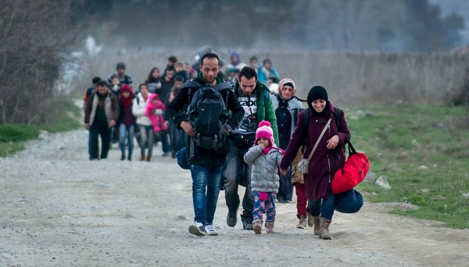  Find an appropriate image of refugees and ask questions about it, or use  https://cafod.org.uk/Education/Primary-teaching-resources/Refugee-resources  (up to 2 mins)  or other ideas from  https://cafod.org.uk/Education/Primary-teaching-resources/Refugee-resources  Jesus, friend and brother, You know what it is like to be hungry and thirsty. You know what it feels like to be a stranger who is made unwelcome. You know the suffering of all who have lost everything. We pray that by welcoming refugees we may show love for our neighbour and be closer to you. Amen. | WHAT DOES THIS MEAN FOR ME?  Luke 10:35-37  Use/adapt according to the age of the group for reflection on the story of the Good Samaritan  I wonder if it matters if the person who needs help is different to you. The story of the Good Samaritan shows us that when someone needs help they are sharing that part of being human that is the same for all of us. We all need help now and again.  I wonder what to do if I see problems that are so big I can’t help. This can happen. You may not be able to do something to help on your own and you always need to remember the things you have been taught about keeping yourself safe. There are lots of charities that are there to help, so by helping them you can help others. Just taking the time to ask about it shows you care and are wanting others to belong.  I wonder if doing a small thing to help someone still counts. All those small things make a big difference. People feel loved and wanted when you show kindness towards them. That is why Jesus told the story. We can all be the Good Samaritan and we can all be helped by a Good Samaritan too.  The story of the Good Samaritan reminds us that we all have neighbours, and that we are all worthy of care and love. If you feel alone, it’s important to reach out and talk to someone you can trust.  Draw the outline of a person. How many ways of being compassionate can you add over the course of today? | CELEBRATE  Philippians 1:3-4  Be thankful with joy for those who have been good neighbours in your class and school this week (see Bible verse above). Commit to being better neighbours from now on. Perhaps you could use ideas from the activity in Thursday’s worship:  Say this prayer quietly and do the actions if you want to as you think about how you can be a Good Samaritan day by day:  These hands were made for kindness (turn hands face up)  My heart was made for love (place hands over heart)  My words speak my compassion (touch lips with your finger)  My eyes see a chance for me to make a difference to someone (shape our fingers like glasses around your eyes)  So everyone knows they belong and no one feels alone (hug hands together) AMEN
Week 4 | WHAT IS THE GOOD NEWS THAT JESUS BRINGS?  John 4:1-26  Safeguarding Note: It is really important in an act of worship about knowing you are loved to be clear about what healthy expressions of love look like and to be sensitive to pupil’s responses.  You will need a glass (ideally a tall, high ball one), a jug of water and something to catch overflowing water. Start with the glass three-quarters full.  Watch an animated version of the Woman at the Well  https://www.youtube.com/watch?v=6Vf3rqnoG5c  https://www.youtube.com/watch?v=pNxNWv6KZ7s  I wonder what more we might want to know or need to know about her.  For a script to use with a glass (ideally a tall, high ball one), a jug of water and something to catch overflowing water to illustrate how Jesus helped the woman at the well, see the engagement section of Faith at Home Resources, Series 2 - Loved (Primary):  https://www.churchofengland.org/our-faith/faith-home/i-am-school-leader#na  Words for reflection picking up on the ideas of the Bible passage can be found in this song  https://www.youtube.com/watch?v=LA9UfBEHciY  Dear God, Thank you for knowing us, welcoming us and loving us. We think of those who feel unloved or left out. Please show us if any of our family, friends or school community are feeling this way, and help us to show them love and kindness as Jesus did at the well. Amen. | WHAT DOES THIS MEAN IN MY SCHOOL AND LOCAL COMMUNITY?  John 4:13-14  This is an opportunity to think of some particular school and community examples to use in worship. Talk about those projects that you support in the local community – food banks, residential homes etc which are ways of sharing ‘living water’ and the love of God with others.  Show an image from the episode in Monday’s worship. Many Christians believe that Jesus’ words about ‘living water’ refer to the unending and life-giving love of God. I wonder how Jesus showed this to the woman he met.  Listen to the song ‘I’ll Stand by You’ by The Pretenders  https://www.youtube.com/watch?v=maAyfcO-X3k and reflect on the lyrics.  I wonder how Jesus ‘stood by’ the Samaritan woman. I wonder who is standing by you. I wonder who you could stand with. I wonder how our school and local communities could be even better at including all and helping all to feel loved and welcomed.  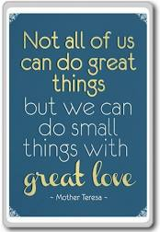  This is a reminder of what each of us can do to love others | WHAT DOES THIS MEAN IN MY GLOBAL COMMUNITY?  Revelation 22:1,17  Throughout the gospels, Jesus is shown as challenging ideas about ‘us’ and ‘them’ – in our episode for the week, we have the example of the ‘Jewish people’ and ‘Samaritans’ – where people were not loved because they are seen as different. In this story, Jesus reaches out to the woman where others might have decided not to. I wonder how our community in our country might be better at including all and helping all feel loved and welcomed across the world. I wonder if we sometimes see what is different about others before we think about what is the same. I wonder if we can challenge ourselves to reverse our way of thinking.  The Bible verses show the importance of water in its picture of heaven (see Bible verses) – ‘the water of life as a free gift’. Our need for water is the same no matter where we live – but not everyone has access to clean water – some facts here, select as appropriate as clip is quite long.  https://www.youtube.com/watch?v=UzRdJc-vPjM&list=PLc-oawSTlDS1PfrZZVSRDs4s1nPcVeaEM&index=2  Here is a challenge to help thinking about the divide between what we and others have /have not.  https://www.wateraid.org/uk/get-involved/teaching/ks2-resources  Dear God, give me a better understanding of how to love others because we are all your children no matter where in the world we live and no matter what our life experiences are day by day. AMEN | WHAT DOES THIS MEAN FOR ME?  John 13:34  Think about the story of the woman at the well and how her ‘glass’ was filled.  Look again at the idea that every bit of love we receive in a day fills our glass a bit more. Every bit of love we give fills the glass of someone else a bit more.  You might give a picture of a water container to pupils who can write a list of their ideas starting at the bottom and filling up the container – perhaps they might come to add some ideas in the morning and come back to it at the end of the day to reflect on what they have given or received to fill the container during the day.  Running water: The story of the Woman at the Well uses water as a symbol for love. Perhaps going forward, every time you use running water (to wash your hands, to make a drink, to brush your teeth etc.), you could reflect on this story and consider how you are loved, accepted and known. This is also a way to reflect on the blessing of having access to clean, running water which is not enjoyed by many of our sisters and brothers across the world.  From Come and Praise:  https://www.youtube.com/watch?v=H30QEVBMndA  Water is for Life - World Water Day song 2011  https://www.youtube.com/watch?v=xn62e5ZJDqs | CELEBRATE  John 13:34  Jesus said, ‘Love one another’. He didn’t say, ‘Love the whole world’.  Teresa of Calcutta  I wonder what Mother Teresa meant.  I wonder who has shown small acts of love in school this week – actions which show that they know us, welcome us and love us. I wonder whether these actions which show that we love one another might be the first step in showing that we also love the world.  This takes up the theme of the Bible verse  https://www.youtube.com/watch?v=485btt72V2o  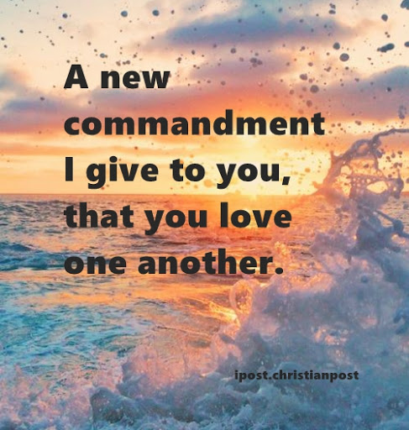
Week 5 | WHAT IS THE GOOD NEWS THAT JESUS BRINGS?  Luke 19:1-10  I wonder if you have ever lost your way when following a map. I wonder if you have ever felt that you have lost your way on your life’s journey.  In the gospels, Jesus tells us that the Gospel (good news) includes a promise that when we make mistakes (and we all do), it’s what we do after that makes the biggest difference. We can get back on track and put it right if we choose to.  Read the story of Zacchaeus (Luke 19:1-10). There are some great photographs showing a retelling of the story here:  https://www.freebibleimages.org/photos/lumo-zacchaeus/  or a clip  https://www.youtube.com/watch?v=5BjtbJFz2ug  I wonder what the people in the crowd were thinking during all of this.  Jesus wanted to eat with a known sinner who had treated them all very badly! Sometimes Jesus surprised people. Jesus went to Zacchaeus’ house and Zacchaeus was so moved by Jesus and his words that he repented (an important word meaning that he changed his mind and said sorry). He knew just being sorry was not enough. He needed to repair the damage. So, he told Jesus that he would give half of his possessions to the poor and, if he had cheated anybody, he would pay them back four times the amount. He was not just making it right, he was making it better.  I wonder if we can spend a few minutes thinking about how we can say sorry for a wrong we have done and committing to do something to repair the damage. | WHAT DOES THIS MEAN IN MY SCHOOL AND LOCAL COMMUNITY?  Matthew 6:12  Find a tree in your imagination. I wonder if you can imagine what you could see from the top. I wonder what you might you be able to see from up there that you can’t see from the ground. When Zacchaeus had a problem, he climbed a tree so he could see further and clearer.  I wonder whether there are problems in our local and national communities that need some clearer thinking.  Use a tree to make a display. Add the suggestions of the problems in our communities that we need to be sorry for on leaves of one colour. I wonder if we have any solutions to these problems. Add the solutions next to the problems on leaves of a different colour. Take some time to ask God to forgive people for the things that they do to spoil or harm our local and national environments.  Use the Lord’s Prayer – focus especially on the words ‘Forgive us our trespasses (sins) as we forgive those who trespass (sin) against us.’ It is a constant rhythm of forgiving and being forgiven that gets us back on track.  https://en.wikipedia.org/wiki/Reconciliation_(Josefina_de_Vasconcellos_sculpture)  Reflect on this image called ‘Reconciliation’ – I wonder how this might help us to think about ‘putting things right’. | WHAT DOES THIS MEAN IN MY GLOBAL COMMUNITY?  Psalm 89:11  The Psalm says that the earth belongs to God. The song below with images could start a discussion about how people have made bad choices and affected that world and also people’s lives  https://www.youtube.com/watch?v=3kVHKuldZyw  I wonder in what ways we can imagine the world as a better place. I wonder if we could all use our generosity and our kindness to inch just a little bit closer to that better world.  Christians believe that Jesus shows us how to live and he shows us that we are loved, which helps us to love ourselves and want to be the best version of ourselves. However, Christians also believe that we have ‘free will’, which means it is up to us if we want to change our minds or not. It is our choice. If we have made mistakes and lost our way, including for our world, Christians think that turning to Jesus can help us to get back on track.  Use the pupils’ ideas to pray that people will say sorry for what they have been doing to the world, change their behaviour and make the world into a better place for everyone who shares the planet.  Creator God, who made our beautiful world, forgive us for the times we cause it harm; for the times when our way of life affects our neighbours.  Inspire us to care for the environment; to help rebuild lives and communities; to share in the griefs and anxieties, joys and hopes of all your people, so that all your creation may flourish. AMEN | WHAT DOES THIS MEAN FOR ME?  Luke 19:1-10  Re-cap on the story of Zaccheaus.  Jesus was pleased - he told Zacchaeus that salvation had come to his house. That meant he had chosen the right things and could follow Jesus with peace in his heart, that he had repented and repaired his mistakes. Sometimes we have to ‘climb a tree’ and look at what we have been doing, even if we have been doing it often, and ask for help to find a way to make it right again.  This story not only tells us not to cheat people or do them harm, it also tells us what we should do if we do hurt someone and we want to repent (turn around and get back on track):  • Change your mind and say sorry (this is repentance)  • Make it right (return what was taken, repair what was broken, soothe what was injured)  • Make it better (if you can, do something that communicates that you understand you did wrong and now you want to show the opposite, doing good  Take some time to think about how you could follow these 3 steps. Perhaps you could use a sorry box in your classroom. Write down on one side of a piece of paper what you are sorry for doing or thinking and on the other side what you are going to do to put in right. Put it in the sealed box to commit to the actions –God knows what you have said – it is your prayer to God or your reflection for your own life | CELEBRATE  Proverbs 17:9  ‘Whoever forgives someone’s sin makes a friend. But the one who tells about the sin breaks up friendships’.  Think of ways of celebrating the good choices that have been made in school this week including those which have asked for forgiveness and helped to get people back on track.  Some words to help with reflection:  The weak can never forgive. Forgiveness is the attribute of the strong.  Mahatma Ghandi  Let us forgive each other - only then will we live in peace.  Leo Tolstoy  Without forgiveness, there's no future.  Desmond Tutu  Forgiving God, lead me to forgive others. Guide us all with your love so that together we may build a more peaceful and just world. AMEN
Week 6 | LENT: JESUS IS TEMPTED  Matthew 4:1-11  I wonder if there are things happening in the world that make you sad and what you might do. Jesus had to think about how he could save the world.  Explore the Bible passage like this or in your own way:  The devil came and spoke to Jesus. Jesus was very hungry like lots of people in the world today. So, did he make huge quantities of bread to feed the hungry? Now that would be a good idea! (Get everyone to agree.)  WHAT? JESUS SAID 'NO' TO THAT!  The devil took Jesus up a high tower and told him to jump off and perform a spectacular party trick. So, did he use his power to perform a big miracle? Now that would be a good idea! (Get everyone to agree.)  WHAT? JESUS SAID 'NO' TO THAT TOO!  The devil showed Jesus the whole world and invited him to join forces to conquer every kingdom. So, did he get a big army together and stop all the wars by military superiority and then take over as a super king? Now that would be a good idea! (Get everyone to agree.)  WHAT? JESUS SAID 'NO' TO THAT TOO!  What Jesus chose to do looks ahead to Easter but we can have a picture in our minds about what Jesus did. Wrap a bandage around a globe with a horizontal band around the equator and a vertical band from pole to pole to give a cross shape. Jesus battled with all the bad things in the world and took them to the cross with him. But Christians believe Jesus came back to life again (unbandage the world) and that Jesus can help us one by one, make a difference in this world for the better. The Bible says God has a job for everyone to do, to mend this hurting world. Spend time praying for our hurting world. | LENT: A TIME FOR THINKING  Matthew 6:12  It may be Ash Wednesday during half term. Talk to the children about Ash Wednesday as the first day of Lent which is a time of thinking about God and focussing more on Him instead of the material things around us. Ash Wednsday is a day when we say sorry to God and think about our lives.  I wonder what it means to say sorry and why we might want to do that, especially to people we love. I wonder how saying sorry helps. Encourage the children to think of things they might want to say sorry to God for and give them time to do this.  You could introduce the liturgy below to the children and invite more ideas to add from pupils.  You will need: Ashes mixed with oil, a large or small cross shape/s, a bowl of water, a candle.  Say the words in italics and invite the children to join in the bold type words. As they say their line, encourage them to dip their finger in the ash mixture and make the sign of the cross or a fingerprint on a large or small cross shape.  Thank you, Lord that you love us and hear us when we pray  We are sorry for things we have done that have hurt you and others.  We have not loved you or others as much as we could Lord, we are sorry  We have not helped others as Jesus helped us Lord, we are sorry  We have been impatient Lord, we are sorry  We have been angry Lord, we are sorry  We have been jealous of others Lord, we are sorry  We have told lies Lord, we are sorry  (Light a candle)  Hear us and help us, Lord  Work through us so that we can share your goodness and love in the world  Show us the joy and new life that Jesus brings. | LENT: A TIME FOR DOING  James 2:15-17  Here are some ideas from various organisations that encourage us to ‘take up’ rather than ‘give up’ for Lent, so that it becomes a time when we look outwards and upwards as well as looking at ourselves and at what God wants of us.  https://cafod.org.uk/Education/Primary-teaching-resources/Lent-resources-for-children  https://www.christianaid.org.uk/schools/lent-easter-schools-resources  https://www.tearfund.org/about_you/resources/for_churches/lent_resources/  https://cuf.org.uk/our-campaigns/the-big-pancake-party  (some of these are for previous years but remain relevant – there may be resources for the current year in due course)  God of life, may my choices be guided by your love so that all people may live to their full potential. AMEN  God the Creator, open my heart to change. Lead me to care for our common home, and all my brothers and sisters who share this earth with me. AMEN | EXPLORING SOME LENT QUESTIONS FOR MY LIFE  Matthew 4:1-11  Remind pupils of the story of Jesus being tempted and relate the ‘temptation’ questions and activities below to the story – they can adapted for different ages/stages:  Build a tower: Use Giant Jenga blocks or smaller ones to see how high people will go.  Talk about: I wonder how you decide what is risky to do and  what is safe.  Sand art: Create a collage of a desert scene involving sand, glue, small stones, dead twigs etc  Talk about: I wonder what gives you strength to survive hard times.  Cupcakes: decorate with icing.  Talk about: I wonder what temptations you find hard to resist.  Big world jigsaw: as a group.  Talk about: I wonder how you would go about rescuing the world from the mess we get it into.  Prayer: Write a prayer on a blossom-shape and hang it on a special prayer tree.  Talk about: I wonder who you want to ask God to give strength  to at the moment.  God of justice, give me the strength to do what I know is right. Lead me to help others and to encourage those I meet to do the same, so that all people may flourish. AMEN | CELEBRATE  Romans 12:1  Celebrate things that you might give up or take up when Lent starts. The Bible verse from Romans talks about being a living sacrifice – whether we give up or take up, there is an element of sacrifice in such actions.  Encourage the community to spend time thinking and doing and remind them that it will be interesting to find out how people are getting on after the break.  God of love, may I be compassionate as you are compassionate, and generous as you are generous. Through me, may others know of your love. AMEN  God of joy, help me to see that true happiness comes from you. Fill me with your love and lead me to serve others in whatever way I can. AMEN  Lively song about giving  https://www.youtube.com/watch?v=Hl6rICWzz0g

