Worship in the classroom
Additional practical ideas

Context
This document complements the ‘Fresh Approach guide to planning and leading worship’, ‘Worship in the classroom’, ‘Making the most of leading worship in the classroom’ and the termly diocesan collective worship plans.

Please find further guidance and termly collective worship planning on this page.

There are three suggestions below, which are additional ideas written to reduce the planning burden on class teachers. One of these ideas could be used each week alongside the schools’ current worship planning.
Pages 5-9 – Praying around the news
Page 10 – Exploring nature
Pages 11-12 – Sharing good news

Structure of collective worship

This structure provides a scaffold for collective worship wherever you are; Gather, Engage, Respond and Send. There are some key features within each section which ensure that your act of worship is distinctively Christian.(see table below) How you fill each ‘column’ is up to you and your class.
Gather | Engage | Respond | Send
How will you signal that worship has begun?  What will you do to begin worship?  Light candle  Opening liturgy | What is the key message for the act of worship?  How will you share the Bible text or story?  What questions will you ask? “I wonder ..” | How will the children respond to the story/message?  What opportunities will there be for prayer, reflection and stillness? | What key thought or message will you ‘send’ the children out with?  How will you signal that worship has ended?  Blow out candle  Closing liturgy
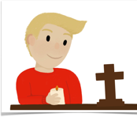  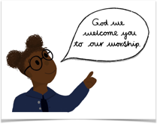 | 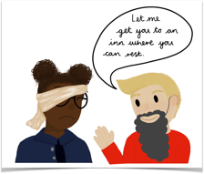  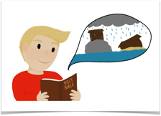  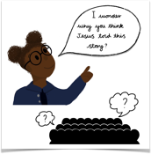 | 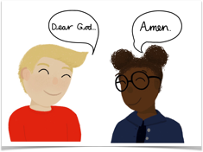  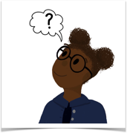 | 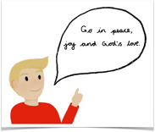  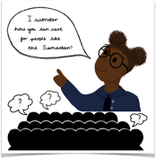  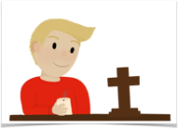

Top tips for planning and leading worship in the classroom

- Set up some clear routines for starting and ending worship so the children become familiar with your class pattern of worship.
For example:
- Play a piece of quiet worship music to signal it is time to prepare the room for worship.
- Change the lighting if you can.
- Change the position the children are sitting in, could they come and sit on the carpet or could they move their chairs?
- Create a visual clue that worship is beginning by preparing your worship table.

- Create a worship box, which contains items for your worship table. E.g. Bible, cross, candle, table cloth. This will make it much easier to set your classroom up for worship.

- Keep it simple. It is much better to take one Bible story or passage of scripture and ask a few open questions about it, than over complicate it with too many ideas.

Remember, it must feel like a Christians act of worship not a PSHE lesson or P4C session.

- Involve your pupils!
  - Set up a rota of children to set up the worship space as you prepare yourself to lead.

  - Ask groups of children to lead the whole act of worship or elements of it each week.
Could they;
    - Open and close worship by sharing the greetings and lighting the candles.
    - write and read the prayers
    - choose a Bible story to share with the class and then think about the questions they could ask to discuss the this story
    - Bring a news story they would like to think and pray about. (See below for guidance on this.)
    - take responsibility for collating and displaying the written prayers.
    - Prepare a short PowerPoint to lead the act of worship through.

It is amazing how quickly they mimic your pattern and are able to ask and discuss open ended questions with their peers. Worship in the classroom is a great training ground for all pupils to lead some or all of an act of worship.

(See Resources – William and Lucy lead collective worship to develop your pupil leaders further.) https://www.canterburydiocese.org/childrenandyoungpeople/our-schools/collective-worship/william-lucy-lead-collective-worship/

Questions you could ask when discussing a Bible story or passage of scripture

- I wonder …
- What has happened in this story?
- Where is this Bible passage from? (Old Testament, New Testament – you could use your Big Frieze to help position the story or passage in the big story of the Bible)
- Who wrote this passage / who told this story?
- How might the characters in the story be feeling?
- Why do you think Jesus told this story?
- Is there a hidden message inside this story?
- What might this story teach Christians about God, how Jesus wants his people to live, how they should be behave or act towards others?
- How might it make Christians feel when they hear this?
- How does this story / passage make you feel?
- What difference might this story/ passage / teaching from the Bible make to you/ your life / your actions?

Praying around the news

Take an item that is in the news, or that has caught the interest of your class this week. Consider the impact this news story has on the people involved. Then spend some time praying for the situation and those affected.
You might like to put a marker on a globe for places you have prayed for or create a world prayer map in your prayer space for children to add their prayers too.
How could your pupils could plan and lead this?

https://www.prayerspacesinschools.com/resources/32 - See this prayer space idea.

Suggested structure and ideas for praying around the news act of worship
Gather | Engage | Respond | Send
This is the day that the Lord has made.  Let us rejoice and be glad in it.  Amen  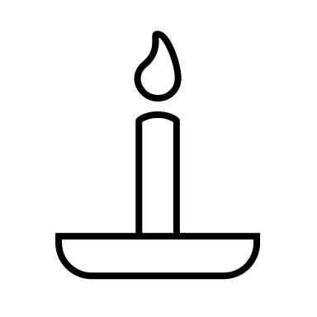  Light your candle | In our worship today we are going to be watching a clip from the news. (See below for suitable websites)  When we have watched it, we are going to think about what the people involved must be going through and how they might be feeling. We are then going to pray for this situation and add them to our prayer map.  The Bible teaches Christians that they have a responsibility to pray; pray for all people, the situations they find themselves in and for those in charge and those helping practically.  Share this Bible verse together.  First, I tell you to pray for all people. Ask God for the things people need, and be thankful to him. You should pray for kings and for all who have authority. Pray for the leaders so that we can have quiet and peaceful lives—lives full of worship and respect for God. 1 Timothy 2: 1-3  I wonder what this verse teaches Christians about what to pray for? We are going to try and do that now  Watch a clip from the news, then discuss:  - What is the situation?  - Where is the situation?  - Who is involved?  - What has been the impact?  - Who is there helping?  - What things do you think we need to pray for?  - How it makes you feel? | We have come together to pray for the needs of the world.  Lord hear our prayers.  You could: (Choose one of these ideas each week)  - Ask children to write down their prayers for the situation on post it notes and add them to your prayer map or prayer area.  - Write a class prayer together, which you could say together for the situation. Put it up in your classroom to say at other points in the week.  - invite a couple of children to say a prayer out loud on behalf of the class.  - Use the hand prayer format below.  - Sit quietly, with an image of the situation on the screen for the children to reflect on and say their own prayers silently.  - Draw your feelings or prayers on some paper to add to the prayer area.  - Shout prayers – allow the children to write a feeling word or an action word (e.g. HELP!) on a graffiti board to indicate how this situation makes them feel.  - Paper chain of prayers. The children could work in small groups to write a prayer on a slip of paper, which can they all be gathered together each week to create a long chain of prayers.  Don’t forget to reflect back and see if your prayers have been answered- has the situation has improved or got better? | I wonder how the situation we looked at today made you feel?  Prayer is one way of helping, but I wonder if there is anything else we could do to help this situation?  Keep thinking about this situation and the prayers that you have prayed today.  May you be filled with God’s peace, joy and love.  Amen  Blow out the candle

Hand prayers – praying around the news
Could you use your hands to pray?
As you point or hold each finger say a prayer linked to each heading.
Below are some words that could help to create your prayers. Amend and tweak to suit the situation you are praying for.

Middle finger - Pray for those in charge.

e.g. Dear God we pray for those in charge of … Guide and fill them with wisdom so they can make sensible, practical decisions to help all those in need. Amen

Index finger - Pray for the agencies involved.

e.g. Dear God, thank you for all the agencies that are helping in this situation, especially the emergency services and charity groups. Will you enable and guide them so they know how to support all those in need in the best way. Amen

Ring finger - Pray for the local church and community.

e.g. Dear God, please will you help the local church and community reach out and help those affected…
Thank you for the kindness and support they are offering, both practically and prayerfully. Amen

Thumb - Pray for change.

e.g. Dear God, this situation really makes us feel ….
We pray that you will bring healing to those that are ill or injured, peace to those who are distressed and comfort to those who are grieving.
We ask that you will inspire people to bring about change so this situation doesn’t happen again. Be with all those who are campaigning for peace and equality for all.
Help us to help and stand up for those who do not have a voice. Amen.

Little finger - Pray for those affected.

e.g. Dear God, we ask you to take care of /be with all those affected by … / caught up in … / involved in …
We ask that you come alongside them and bring them your comfort and peace and provide all they need. Thank you God that you promise to look after all your people. We place ….. before you now.
Amen

Suitable news websites for using within collective worship (With thanks to Guildford Diocese for collating these websites)
Take care! It is important to avoid using ‘Fake News’! This material from The Guardian is helpful if you are letting pupils select the news stories that you are going to use.
https://www.theguardian.com/newswise/2018/sep/17/newswise-navigator

Primary
BBC Newsround - https://www.bbc.co.uk/newsround
Items from the current news put into a form that is suitable for pupils in KS2 and above. Do check that the content is suitable for the background and experiences of the pupils in your class.

Dogo News https://www.dogonews.com/
Online news site for children with stories written from an international perspective. Upper KS 2 and secondary.

News for Kids - https://newsforkids.net/
Daily roundups of current news written for children, including explanations of unfamiliar terms. US-based but includes worldwide stories.

Positivity Place - https://live.firstnews.co.uk/positivity-place/
A source of positive news stories for children.

Picture News – https://www.picture-news.co.uk/
Each week they choose a current news story, provide an image, a thought-provoking question and a variety of teaching resources.
Online primary version is £130 a year. There is an EYFS version £80 a year.

Secondary
BBC What’s New? https://www.youtube.com/c/BBCWhatsNew/featured
A news programme for young people in Africa aimed at 11- to 16-year-olds. A weekly broadcast is available to watch on their YouTube channel. They also include stories about children doing remarkable things in different African countries.

Dogo News https://www.dogonews.com/
Online news site for children with stories written from an international perspective.

Global connections – World prayer news https://www.globalconnections.org.uk/prayer
This website gives prayer points for different situations around the world.

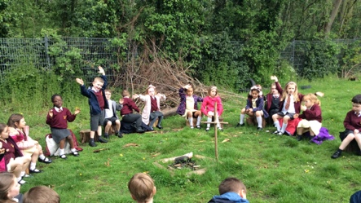
Exploring nature

Could you go outside of your classroom and enjoy the nature around you? Do you have a forest school area, local park or beach where you could hold your worship? Many people meet with God through nature, so why not explore and notice what has been created?

Suggested format for worship in Nature
Gather | Engage | Respond | Send
Creator God, we thank you for all you have made, help us to enjoy creation together.  Amen  If appropriate or possible, light a candle or a small fire as a sign that worship has begun.  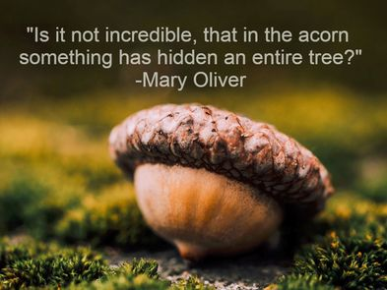 | You might like to read this psalm. I wonder why the psalmist wrote this, how do you think they were feeling? Where might they have been?  Look at the splendour of your skies,  your creative genius glowing in the heavens.  When I gaze at your moon and your stars,  mounted like jewels in their settings,  I know you are the fascinating artist who fashioned it all!  Psalm 8:3 (TPT)  Allow the children time and space to wonder silently or just sit still in creation; what can you hear, feel, smell, touch? How does it make you feel?  What signs can they find that make them think of God as creator?  Celebrate the amazing nature you are in; from conkers to the changing colours of the leaves, new plants growing, colours in the sky, bird song, birds in flight, tiny insects a spidersweb for example.  Allow time to marvel at these things and the intricases of them all. | Invite the children to create something beautiful out of the nature around them. E.g. a rainbow or plant?  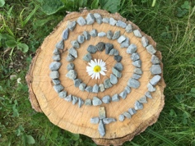  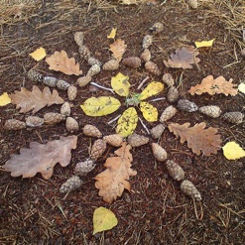  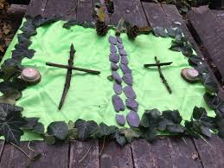  Maybe the could find some materials to make a cross?  Allow the children time to look at everybodys creation.  Pray together  Thank you God for creation, thank you for all the animals, plants, seasons and the beautiful colours that surround us. Help us to care for and love all of creation. Amen | I wonder how being outside for worship has made you feel today?  Ask the children how would you finish these sentences (based on Psalm 8:3)  Look at the splendour of …  When I gaze at …  I feel …  When I touch …  I know …  Go in peace, go in joy, go in love to care for each other and the world.  Amen.
Sharing Good news!

There were many stories of hope and good news being shared during lockdown, this brought so much joy to those listening. Why not bring these stories of hope and joy into your classroom.
Celebrate the lives of your class, encourage them in all they are doing to live out the vision and values of the school.
You might also like to share a good news story from the News, so the children understand the world isn’t just full of bad news.

Therefore encourage one another and build one another up, just as you are doing.
1 Thessalonians 5:11

Suggested format for Good News worship
Gather | Engage | Respond | Send
This is the day the Lord has made.  Let us rejoice and be glad  Amen  Light your candle | Therefore encourage one another and build one another up, just as you are doing.  1 Thessalonians 5:11  I wonder why Paul wrote these words in his letter to the people of Thessalonica? What did he want the people there to do?  Why is it important to encourage each other? How does it make you feel when someone says something lovely about you?  The focus of today’s act of worship is going to be sharing good news and encouraging each other. Sharing good news can bring us hope and remind us of the good things in our world and lives.  You could ask:  - “Who would like to share a good news story?”  - “I wonder if anyone has spotted someone in our class living out our vision or one of our values?”  - “I wonder if anyone would like to share something they have done or achieved that they are proud of?”  - “Is there anyone who wants to thank someone in the class for something they have done?” | Pray together – Give thanks to God for all the good news stories. Thank God for each other and pray for the situations you talked about in the engage section.  You could say this Bible verse together as a blessing over each other:  The Lord bless you and keep you; the Lord make his face to shine upon you and be gracious to you; the Lord lift up his countenance upon you and give you peace.  Numbers 6:24-26 | Don’t forget to be on the lookout for good news stories, look for the hope in the everyday.  Also, think about your words, make sure you use them to encourage and build each other up.  Go into the world to walk in God's light, to rejoice in God's love and to reflect God's glory.  Amen  Blow out the candle

