Our School: Together-Apart
Rebuilding Community: Sharing your story

A note for parents and carers:
At school, your child will be used to taking part in collective worship every day (they might call it ‘assembly’). This is not the kind of worship that some of you might be have been part of in a religious building. In church schools this collective worship is planned to be:
- Inclusive: something for children and teachers, of all faiths or of none to be able to join in with
- Inspirational: a time in the day to think about the big questions in our lives; an occasion that supports the school community’s spiritual development, creates an opportunity to gather around and reflect on a common theme and ‘feeds’ their inner being;
- Invitational: in school, children and teachers are invited to pray, think, or reflect, it is the child’s or teacher’s choice how they respond.
As you know, some children are returning to school, whilst others are not. These resources are for the children at home, to help provide that sense of normality, and prepare them for their return in due course. They will be similar to materials we have prepared for use in school, helping your school community to feel that it still belongs together. Please be clear: these ideas are for you to use, adapt, or not use at all. You choose!

Theme: Sharing your story
- You will need the picture of the Torah scroll (overleaf) or at https://pixabay.com/photos/torah-scroll-israel-jewish-4299038/ This scroll is the sacred holy book for the Jewish people and is referred to in the story on p.3
- For the reflection, you will need a piece of paper each, to make a ‘scroll’ of your own
Things to talk about together:
- Look at the picture of the scroll. What do you think it’s for?
- What do you think the words are saying?
- The scroll contains words that are very important to Jewish people. What words are important words to you?
- In the story, Ezra the teacher read out the rules that God had given to his people through Moses. People sometimes call them the Ten Commandments. What do you think they were? [You can find them in Exodus chapter 20]
- What ‘commandments’ would you make for this time in ‘lockdown’ – especially as it begins to ease?
Things to do together:
- Share the story of ‘Nehemiah’s Big Rebuild, part 2’ together, joining in the actions and using the wondering questions at the end. The reflective activity explains what to do next.
- Roll your ‘scroll’: To avoid frustration, it’s best to roll your scroll after you’ve written on it, which is explained in the reflection section. If you want to make your scroll rolled like the Torah, tape a stick or pencil on each short side, then roll the scroll up from each side, around the pencil and into the middle.
- ‘Share your stories’: After you’ve used the reflection time to make your scroll ‘tell your stories’ to each other. Are there things you can learn about each other from the ‘stories’ you tell?
- Make a big ‘family-sized’ scroll like the people did, and write on it your household ‘rules’, or some promises you’d like to make to each other, as you continue this time doing ‘school at home’ together.
Things to reflect on or pray about together: you will each need a piece of paper
We’re going to use our piece of paper to make our own scrolls – and to help us to think.

The people heard stories from their past: stories that reminded them of who they were – and the things that should have been important to them. Some of the memories made the people sad, and some of them made the people happy. Both feelings are OK.
….I wonder what’s been important to you during lockdown?....….I wonder which words have been important to you in this time?....I wonder what stories you might tell to others about your lockdown experiences?....….take some time to write or draw your thoughts onto your scroll….

If you want to pray together, you could use these words, which the people prayed as they gathered together:
‘God, Blessed be your wonderful name. Your name is more wonderful than all blessing and praise. You are the only Lord. ….You give life to everything. Because of your mercy, you saved us again and again.
You were patient with us for many years. ....our God, you are the great and mighty and wonderful God.
You keep your agreement of love.’
[You can read the much longer prayer that the people prayed in Nehemiah chapter 9. This prayer is from verses 5-6, 28, 30 & 32 in the International Children’s Bible]

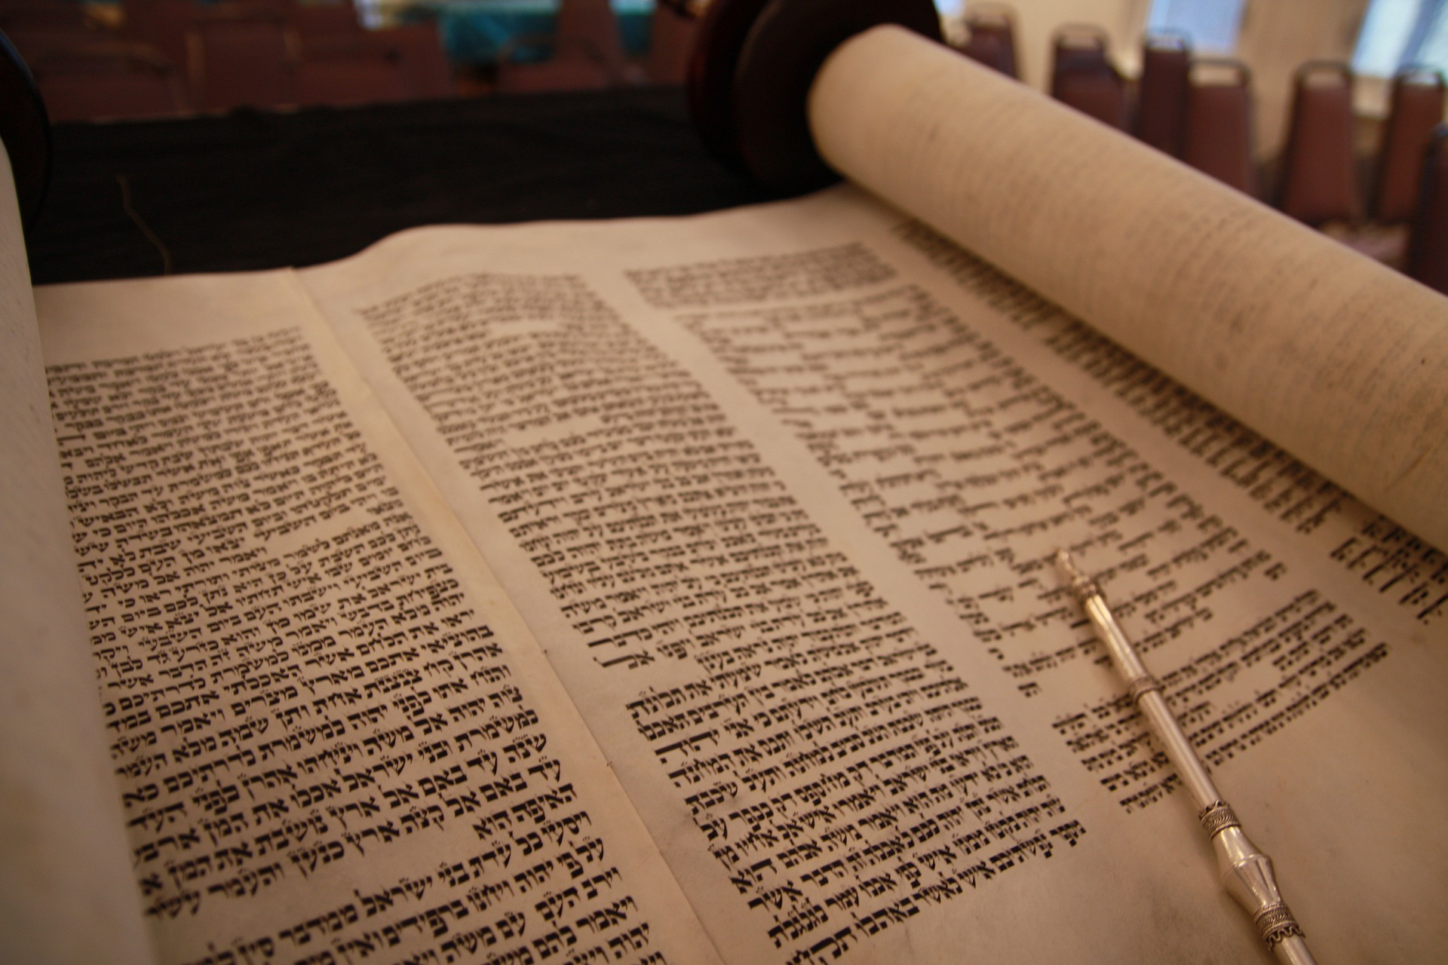

Nehemiah and the Big Rebuild (Part Two)
To help children to engage: every time you hear the word ‘hearts’ make a heart shape with your hands

As we heard last time, Nehemiah was not a builder: he was the cup-bearer to the King of Babylon, who had been sent to Jerusalem to rebuild the city, the home of the people of God. Most of God’s people had been living far, far away from home, in a land called Babylon. Their hearts had not forgotten about Israel, their ‘home’, but the people had never imagined that they would ever be able to return there.

The re-building of Jerusalem had taken seven months until there were homes for people to live in and some of them had returned from Babylon. But God, and Nehemiah, knew there was more work to do, that the people needed more than buildings and homes – they needed to remember who they were…..to re-build their hearts.

So Nehemiah gathered the people together – and Ezra the teacher read from the sacred scrolls containing the teachings of Moses. The people had not met together like this for a very long time, so long, in fact that they had almost forgotten what being together felt like. Their hearts were full of joy – and they worshipped God there together.

As Ezra read on, the people heard the stories of how God had been with them in the past: how he’d rescued them from Egypt and provided for them on their long journey to the land that God had promised them, their home. Their hearts were full of hope, as they remembered that God had been with them all this time.

They listened to Ezra read the rules that God had given to Moses many years ago and thought about what they meant, but then, suddenly, they realised how sad God must be that they had forgotten his rules….and as great big tears fell from their eyes, their hearts were filled with sadness. But God was using this sadness to help mend their broken hearts; to help the people to remember who they were and the things that should be important to them – the things that really mattered to God.

Nehemiah looked at the people and knew just what to do. ‘Don’t cry!’ he said. ‘This is a great day: a day for us to remember and be glad that we are God’s people. His joy will make your hearts strong!’ And he sent them home to eat, to drink, and to celebrate – and to share their food with those who were in need.

When they gathered the next day, the people heard how God had given them a way to celebrate that they were his people – and to remember his faithfulness on the long desert journey long ago, when they lived in tents. As God had told them to, they gathered branches from the trees – and built shelters on their rooftops, shelters in the courtyards and shelters in the grounds of the Temple. The people gathered up all their words of praise into a great prayer. Then they made promises to each other and to God and signed a charter to remind them of who they were, and what they had promised.

And as they celebrated, their hearts were rebuilt, just like the walls of the great city had been.
And God’s heart was very glad!

I wonder…..
…how the words that Ezra read from the Torah helped to rebuild the peoples’ hearts?….
….why the great stories of their past helped them to remember who they were?….
….and how the stories reminded them of who God was?….
….why the words gave them a reason to celebrate….

….Nehemiah wrote in his story that there had never been a celebration like it!....
…..I wonder why?.....

